Local 935 Policy Manual

February 2022

President/Business Manager

The President/Business Manager shall follow and support the direction of the Executive Board and the General Membership.

The President/Business Manager is the focus of Union policy and direction.

The President/Business Manager shall keep all personnel issues confidential.

The President/Business Manager shall attend all General and Executive Board meetings.

The President/Business Manager shall attend political functions and meet with officials.

The President/Business Manager shall meet with fire officials as necessary to promote good communications.

The President/Business Manager shall attend the IAFF Convention, CPF Convention, CPF District Meetings, and Legislative Conferences or appoint a designee. The President may also attend ALTS, HR Conference, or other organized events or conferences that are deemed of benefit to the Local.

The President/Business Manager shall obtain coverage for duties by another Executive Board member during absences.

The President/Business Manager shall keep the Secretary, Treasurer, and Executive Vice Presidents currently and fully informed on all matters concerning the business of the local.

The President/Business Manager shall appoint Committee Chairs subject to ratification by the Executive Board.

The President/Business Manager shall use Union Business for duties of the elected office with regard for travel, distance, time, and impact on others members

Executive Vice President

The Executive VP shall report directly to the President/ Business Manager

The Executive Vice President shall follow and support the policies and direction of the President and Executive Board.

The Executive Vice President shall keep all personnel issues confidential.

The Executive Vice President shall attend all General and Executive Board meetings, and stay fully informed of all matters concerning the Local.

The Executive Vice President may attend the IAFF Convention, CPF Convention, CPF District Meetings and Legislative Conferences, ALTS, HR Conference, or other organized events or conferences that are deemed of benefit to the Local.

The Executive Vice President shall obtain coverage for duties by another Executive Board member during absences.

The President/Business Manager shall assign the following: One Executive VP shall be responsible for Division 1, 2, 3, 4, 5, 6. The other Executive VP shall be responsible for Division 11, Affiliate agencies, Retirees, Trustees, Merger Reps, and SBCERA Rep. Both Executive VPs shall keep the President/Business Manager currently and fully informed of their activities.

The Executive VP shall use Union Business for duties of the elected office with regard for travel, distance, time, and impact on others members

Vice President

The Vice President reports to his/her assigned Executive VP.

The Vice President shall follow the policies and direction of the President and Executive Board.

The Vice President shall follow and support the policies and direction of the President and Executive Board.

The Vice President shall keep all personnel issues confidential.

The Vice President shall attend all General and Executive Board meetings, and stay fully informed of all matters concerning the Local.

The Vice President may attend the IAFF Convention, CPF Convention, CPF District Meetings and Legislative Conferences, ALTS, HR Conference, or other organized events or conferences that are deemed of benefit to the Local.

The Vice President shall obtain coverage for duties by another Executive Board member during absences.

The Vice President shall keep their Executive VP currently and fully informed of their activities.

The Vice President shall use Union Business for duties of the elected office with regard for travel, distance, time, and impact on others members

Secretary

The Secretary shall keep records of all official meetings.

The Secretary shall be the scribe of the General meetings, Executive meetings or other meetings they attend. These shall be in the Book of Minutes.

The Secretary shall keep record of the location of the inventoried union items.

The Secretary shall document activities or other information in the Union Record. On the Union website

The Secretary shall maintain the Policy manual.

The Secretary shall keep union documents in a secure place as long as legally required.

The Secretary shall have at all meetings the following documents: IAFF C&BL, Local 935 C&BL, Manual of Common Procedure and Subjects, Atwood’s Rules for Meeting, Policy Manual, and the Book of Minutes.

The Secretary shall keep the official seal for union documents.

The Secretary shall keep all personnel issues confidential.

The Secretary shall keep an accurate record of the mailing addresses of members as provided.

The Secretary shall follow and support the policies and direction of the President and Executive Board.

The Secretary shall attend all General and Executive Board meetings, and stay fully informed of all matters concerning the Local.

The Secretary shall schedule transportation/booking arrangements and may attend the IAFF Convention, CPF Convention, CPF District Meetings, and Legislative Conferences, ALTS, HR Conference, or other organized events or conferences that are deemed of benefit to the Local as applicable. Board Members may choose to make their own registration, travel, and lodging arrangements but shall notify the Secretary they are doing so for each occasion.

The Secretary shall obtain coverage for duties by another Executive Board member during absences.

The Secretary shall enforce all standing rules for meetings.

The Secretary shall use Union Business for duties of the elected office with regard for travel, distance, time, and impact on others members

Secretary Job Tasks

Seven (7) Days before Meeting –
Contact the Treasurer, Vice Presidents and President for Agenda Items.
Confirm with President appropriate old business.
Post on website agenda for approval to E-Board.

Three Days before Meeting –
Post on website Meeting Notice with new agenda items. Confirm posting with fire stations and E-Board members.

Two Days before Meeting –
Random Check of Meeting announcement.

Meetings –
Bring Union Notebook with C&BL, Minutes, Policies and Procedures.
Bring Agenda and past minutes for approval
Take Notes
After Meeting
E-mail out Approved Minutes, Record Copy in Union Notebook.
Complete Minutes for approval at next meeting.
Backup Computer Documents.

Trips, Convention and PAC issues.
Coordinate PAC activity and attendance with President, Supervising VP and PAC Coordinator.
Record PAC activity attendance.
Confirm with President attendance for all trips or conventions.
Obtain airfare, hotel rooms and registration for appropriate number of attendees.
Consider Car rental for some locations (smaller cities, larger areas with limited mass transit).

Treasurer

The Treasurer shall keep an accurate record of all union financial transactions.

The Treasurer shall retain all financial records secure for a period of time as legally required.

The Treasurer shall maintain records showing the dues payment status of each member.

The Treasurer shall maintain receipts and disbursement journals (or similar records) to record all monies received and spent by the union.

The Treasurer shall make regular, frequent deposits of dues and other union funds to the union's bank account (s) and identify each deposit with a specific set or time period of receipts in the union's receipts journal to make the relationship between receipts and bank deposits perfectly clear and easily verifiable.

The Treasurer shall contract for audits of the Union’s financial records as required. The Treasurer shall submit the audit, 60 days upon receipt for submission to the IAFF.

The Treasurer shall keep all personnel issues confidential.

The Treasurer shall follow and support the policies and direction of the President and Executive Board.

The Treasurer shall attend all General and Executive Board meetings, and stay fully informed of all matters concerning the Local.

The Treasurer may attend the IAFF Convention, CPF Convention, CPF District Meetings and Legislative Conferences.

The Treasurer shall prepare an annual budget for review by the E-Board.

The Treasurer shall obtain coverage for duties by another Executive Board member during absences.

The Treasurer shall use Union Business for duties of the elected office with regard for travel, distance, time, and impact on others members

ADDITIONAL FINANCIAL CONTROLS AND FISCAL REPONSIBILITY

Ensure that there is a full understanding, in the form of membership or executive board authorizations recorded in meeting minutes, about the level of salary, allowances, and expenses (if any) to which the union's officers are entitled.
Require that all checks drawn on the union's bank account have a second signature and ensure that the cosigner fully understands that his/her fiduciary responsibilities require that the checks be signed only after they are completely filled out and the cosigner knows the purpose and legitimacy of each transaction.
Require that the financial officer give a full report of the union's finances at each membership or executive board meeting and that prior authorization be obtained for large or unusual transactions.
Establish internal local union audit committees (or trustees).
Ensure that the internal audit committee (or trustees) conduct regular, periodic examinations of the union's books and records, including:
Reconciling the union's record of bank account balances with bank statements
Conducting a spot-check reconciliation of receipts with deposits
Spot-checking for possible unrecorded receipts by tracing dues and fees payment entries on membership dues payment records back to duplicate receipts and receipts journal entries.
Ensuring that all cancelled checks that cleared the bank, per the bank statement, have been provided to the audit committee for examination.
Examining cancelled checks for consistency of payee and endorsements and comparing the amount and payee on each check with the information recorded on check stubs and in the disbursement journal.
Ensuring that adequate backup documentation (bills, sales invoices, etc.) is maintained for all union expenditures.
Verifying for purpose and legitimacy of check transactions by referring to check stub and journal entries, back-up documentation, and the membership or executive board authorizations recorded in meeting minutes.
Review established internal controls periodically and change operating procedures as necessary to ensure that the union's funds are being properly handled and adequately safeguarded.

CREDIT CARDS:
The President, Executive Vice Presidents, Secretary and Treasurer shall be issued and be responsible for a credit card for union business. The Secretary and Treasurer may also be issued a second card specifically for registrations and events that do not accept the brand of the primary issued cards. Credit cards may be issued by the Treasurer on a case by case basis and approved by the Principal Board. Upon receiving their credit card the principal member will sign a credit card agreement. A copy of said agreement can be found in appendix C of the policy manual. All credit card transactions shall require a receipt. All receipts will be either photographed via electronic device, or otherwise uploaded into an expense reporting program adopted by the E-board (Certify). The procedure for reporting credit card expenditures outlined in appendix T must be followed. All original receipts shall be retained and turned in on a monthly basis to the treasurer. Original receipts must be submitted with the expense report they correspond to as outlined in appendix T. Failure to maintain receipts for union related expenditures or failure to adhere to the expenditure reporting procedure outlined in appendix T, may result in the forfeiture of the credit card and require the principal member to reimburse the union for said expenditures.

REIMBURSEMENT PROCEDURES FOR CASH EXPENDITURES:
Executive board members shall be reimbursed for union expenditures using their own funds.
All requests for reimbursement shall be accompanied by itemized receipts and reported following the procedure outlined in appendix T. All original receipts must be retained and turned in to the treasurer on a monthly basis. Failure to provide a receipt and or not follow the reporting procedure will result in the reimbursement being rejected unless good cause can be determined and approval is granted by a majority of the Principal Board. Reimbursements will be direct deposited after the expenses have been approved and processed. If the member has not completed the paperwork to comply with the direct deposit procedure the member may pick up their reimbursement check in person at the convenience of the Treasurer. Reimbursements will be mailed at discretion of the Treasurer on a case by case basis.

Local 935 Purchase of Alcohol Policy
Local 935 takes on a liability when purchasing alcohol. Discretion and good judgment must be used if alcohol is to be purchased with union credit cards. Open tabs or excessive charges related to alcohol are strictly forbidden and will result in an immediate deactivation and forfeiture of the union credit card. If damage to property, injury, or death occurs because of the actions of someone who became intoxicated while on union business, or because of the irresponsible purchases of alcohol with a union credit card, Local 935 may be held responsible. In addition, Local 935 has an ethical responsibility to ensure public safety and the safety of our members.

Mileage Reimbursement

All members of the executive board shall be reimbursed for mileage for union related business at the current IRS approved rate. Mileage reimbursements shall be reported as described in appendix T. Failure to report mileage as described in the procedure in appendix T will result in the mileage reimbursement being rejected unless good cause can be determined and approval is granted by a majority of the E-board.

DIRECT DEPOSIT COMPENSATION
All compensated members shall be given 3 months from time of election or appointment to office to complete and return direct deposit enrollment forms to receive their compensation through ACH direct deposit. If after 3 months the member is not enrolled in direct deposit their compensation will no longer be mailed and will have to be picked up in person at the convenience of the treasurer.

Recommended expenditure guidelines by fund
General Fund:
Expenditures from the general fund shall include the following:
Per capita dues to the International Association of Firefighters.
Per capita dues to the California Professional Firefighters.
Per capita dues to the central labor council of San Bernardino/Riverside counties.
Executive board salaries
Any and all taxes and assessments that may be due to any governmental branch, other than related to Local 935 landholdings.
Office expenditures including, but not limited to:
Computers, printers, fax machines, telephones, postage, stationary and any other equipment or device deemed necessary for the efficiency of the organization.
Member events not related to other established funds of the organization.
Reimbursement to members for business related expenditures including conventions, seminars, meetings, meals, mileage, etc.
Business credit card:
Business related expenditures using the issued business credit cards.
Any other expenditures not related to other established funds as approved by vote of the executive board.
All funds received from the membership for the general fund shall be kept in a separate account.

BUILDING FUND:
Computers, printers, fax machines, telephones, postage, stationary and any other equipment or device deemed necessary for the operation of the Union Hall.
Any and all taxes and assessments that may be due to any governmental branch, directly related to Local 935 landholdings.
Mortgage payments and utilities

Political Action Funds:
Expenditures from the political action funds shall include the following:
All expenditures of a political nature affecting local and state candidates; propositions and measures.
Expenditures from the political action funds shall be determined by the executive board (PAC committee) on a case-by-case basis.

All expenditures shall meet the legal requirements of the State of California Political Reform Division and the Fair Political Practice Commission. PAC Treasurer shall be responsible for filing and maintaining all required forms with the state of California political reform division and all local entities as required including both the county of San Bernardino and all cities within its boundaries.
All funds received from the membership for political purposes shall be kept in separate accounts, one account for state PAC and one account for county and city PAC.

Insurance Fund:
Expenditures from the insurance fund shall include the following:
Member premiums for all currently in force insurance policies. These include, but are not limited to:
CAPF long term disability
Aflac
Harry j. Wilson insurance center
Washington national insurance
CAPF Long Term Care

All funds received from the membership and the County of San Bernardino for all insurance policies shall be kept in a separate account.

Legal Defense Fund:
Expenditures from the legal defense fund shall include the following:
Funds to be applied to protect the interests of the local as determined by the executive board.

Expenditures from the legal defense fund shall be determined by the executive board on a case-by-case basis.

All funds received from the membership for legal defense shall be kept in a separate account.

Good & Welfare Fund:
Funds for the aid and benefit of members and families of this local and members and families of other fire locals.

Expenditures from the good & welfare fund shall be determined by the executive board on a case by case basis.

All funds received from the membership for good & welfare shall be kept in a separate account.

Public Relations Fund:
Funds to be applied to increase the image and awareness of the local to the community.

These include, but are not limited to:

Contributions to schools, civic organizations, youth sports leagues, etc.

Expenditures from the public relations fund shall be determined by the executive board on a case-by-case basis.

All funds received from the membership for the public relations fund shall be kept in a separate account.

Pipes & Drums Fund:

Funds for the creation and maintenance of a Pipes & Drums corps.

Expenditures from the Pipes & Drums fund shall be determined by the Pipes & Drums committee.

All funds received from the membership for the Pipes & Drums fund shall be kept in a separate account.

FIREWIRE:
The FIREWIRE magazine was established in January of 2014 by a small group of Local 935 members. This magazine is a digital and print publication that is written, edited and published by several other Local 935 members. The Firewire is published each quarter. It is used as an effective communication tool for the union as well as the County Fire District. Firewire highlights the political mission of Local 935 and also other important areas of County Fire.
Currently the FIREWIRE is funded by Local 935. Advertising revenue ranges from $2500-$3000 per year and we expect that number to increase each year as ad rates are increased with increased distribution. Currently the Ad Revenue is considered surplus in the overall annual budget. The primary editor may use his/her discretion to use those funds as he/she sees fit. The editing staff currently is not compensated for any of this work product. The photographers are also not compensated for their photography. To be able to use those surplus funds to keep the group motivated will secure the overall success of this publication.

Mandatory Mess “CHOW FUND”:
Funds applied toward the mandatory station meal fund.

Funds received from the membership shall be distributed monthly to the station buyers. Station buyers and crews shall determine how the funds will be used for stocking station pantries.

All funds received from the membership for the mandatory mess fund shall be kept in a separate account.
Mandatory mess accounts for each station will be set up through Firefighters First Credit Union. It is the responsibility of the buyer to set up their account. See Appendix M for instructions.

BUDGET

The Treasurer shall prepare an annual budget for review by the E-Board, no later than one month before the close of the fiscal year. The Trustees will review the proposed budget before it is presented to the Board.

The finalized Budget will be voted for adoption at the July General Meeting.

Division Representative

The Division Rep. shall coordinate all union activities in their area.

The Division Rep. shall be familiar with the Division Budget.

The Division Rep. shall represent all members fairly and unbiased.

The Division Rep. shall keep all personnel issues confidential.

The Division Rep. shall follow and support the policies and direction of the President and Executive Board.

The Division Rep. shall attend all General and Executive Board meetings.

The Division Rep. shall meet with the local chief to ensure good communications.

The Division Rep. shall ensure that all Union Boards are in good order.

The Division Rep. shall obtain coverage for duties by another Executive Board member during absences.

The Division Rep. shall keep current of all local political issues.

The Division Rep. shall have general knowledge of the grievance practices and procedures.

The Division Rep shall report to his/her assigned VP. The Rep shall keep the VP informed of activities and events within and affecting their Division.

The Division Reps may appoint a Steward at each station or workplace within their area of responsibility. The Vice President responsible for that area shall ratify the appointment.

The Division Rep shall use Union Business for duties of the elected office with regard for travel, distance, time, and impact on others members

UNION STEWARD

The Union Steward may be appointed by the Representative to serve as the communication link to their workplace.

The Union Steward shall not receive a stipend.

The Union Steward shall not have a vote on the Executive Board and is not required to attend Executive Board meetings.

The Union Steward will ensure the mandatory mess buyer sets up an account with the Local to receive payment for the station members chow fund.

The Union Steward shall keep their Representative informed of any events and activities or members concerns at their station.

Trustee

The Trustee shall not receive a stipend.

The Trustee shall not have a vote on the Executive Board and are not required to attend Executive Board meetings.

The Trustees shall present a report to the Membership at the July General Meeting.

The Trustees shall attend an annual retreat (with dates to be determined by the Treasurer) to review the Previous Fiscal Years Audit, Current Fiscal Years Budget and Proposed next Fiscal Years Budget. Quarterly reviews are encouraged.

The Trustees are encouraged to attend any and all meetings to ensure financial responsibility is being upheld by the Local.

Principal Officers

The mail shall be picked up by the Treasurer or their designee.

The mail shall be picked up on NO LESS THAN TWICE each week.

All IAFF, CPF, and Political Correspondence have the highest priority for routing.

All financial mail shall be routed to the Treasurer.

The only mail that shall not be opened is marked “Private” or “Personal”.

Voting Outside of Meetings

There are instances when the Principal Board must take action on an immediate topic outside of the General and Executive Board meetings. An electronic vote may occur via text message or email format. Principal Board members have four hours to respond to a text request for a vote and 24 hours to respond to an emailed vote, after which they will be considered to have abstained from the vote. The voting results shall be recorded at the next General or Executive Board Meeting.

Committee Member

Committee Members shall have a chair to preside over the meetings. The Chair is appointed by the President and subject to ratification by the Executive Board. Ops Leadership Sub-Committees are formed by the department and shall have at least one representative from the Union.

Prior to any Committee being formed the Local shall solicit members interested in serving on the committee. A survey shall be developed and approved by the reps; that questionnaire is then sent to the membership to be used as sort of a “resume.” Typically there is a 10-14 day window to return the requested information. Once candidates return their questionnaires, the labor reps in their respective divisions review each applicant and formulate a vote. The Reps will select members for the committee, attempting to balance out divisions and include affiliate members when applicable.

In rare occasions a Committee may need to seek the recall or removal of a member. It is best to use this option as a last alternative after substantial discussion and compromises. The Committee Chairperson should first ask the member to step down. If that option is not satisfactory the following steps will be followed. All concerns with the member from other members must be reported to the Chairperson. The Chairperson must then initiate a formal Recall email to the Division Representative supervising the Committee rosters. This email should include a statement from the Chairperson that this email serves as an Official Intent to Recall a Committee member, name the person, and give the reasons for removal of the member. This Intent to Recall email will then be forwarded to all Local 935 Division Representatives for them to observe and evaluate the situation. A vote will be taken of all Representatives with the options of yes, no, or abstain/recuse from the vote. The majority of the vote stands. In the rare case of a tie vote the Local 935 Union President will be consulted and makes the final decision

Local 935 Internal Committees may consist of three or more persons as determined by the Principal Board. Such Committees may include Charitable Events, Union Hall, and other committees the Principal Board deems needed. All Committees are subject to revamping, deletion, and interpretation by the Principal Board.

Committee Members shall seek the guidance of the Executive Board or Union President to seek the Union Position and the will of the Membership on issues. Any and all decisions affecting the wages, working conditions, and benefits of the membership shall be ratified by the Principal Board.

Committee Members shall be prepared at each meeting with required research and work documented.

Committee Chairs shall report to the Executive Board regarding Committee Progress in writing prior to the monthly E-Board Meetings.

Committee Chairs may present a report to Ops Leadership or other committees as required.

Committee Members shall attend all committee meetings. Committee minutes shall be taken at each meeting and forwarded to the Ops Leadership and/or Executive Board as appropriate.

Committee Members shall keep the excellent service delivery as their final objective as they weigh the safety, priorities and other concerns affecting the department and union members.

Committee Report is included in the agenda of each General and Executive Board meeting. Any committee doing business since the last meeting is expected to give a report to the board. The Board may require a written analysis or verbal presentation of any committees work preformed.

Committees shall post meeting schedules. This can be done on the 935 website calendar, or by notifying the Secretary to add the meeting dates and times to the calendar.

The Secretary shall maintain a list of all Committees, their general area of responsibilities, and their assigned members on the Union website.

Permanent Local 935 Committees

Negotiations Committee

Prior to the Local opening negotiations with the County of San Bernardino or their representatives all ranks in the MOU shall be represented on the committee. The Committee shall determine who shall be the Negotiations Team. The Local will poll the Membership for their issues of importance prior to negotiations opening. During the negotiations process the membership shall be kept informed of the progress. Any discussion regarding negotiations with the County of San Bernardino or their representatives shall be attended by at least two Committee members or Negotiations Team Members. Upon the signing of the MOU the sitting members of Negotiations Committee shall be dismissed and a new Negotiations Committee will be formed within 90 days to begin the process for the next MOU. Once seated the members selected are expected to represent the rank for which they were chosen for the term of that Negotiations Committee.

Constitution and Bylaws/Policy Committee

This Committee will evaluate and update the Constitution and Bylaws and the Policy Manual. The Committee will ensure the Local abides by the Constitution and Bylaws of the International Association of Firefighters, the California Professional Firefighters, and all laws. Any members suggesting changes to these documents shall submit their recommendation to the Committee.

Union Hall

The Vice President of the Division in which the Hall is located shall be the Chair of this Committee. The Union Hall Committee shall responsible for the maintenance, cleaning, and upkeep of the Union Hall, and any union property stored there. The Fire Station physically closest to the Hall shall be issued a key to allow members access as needed.

Political Action Committee

The Principal Board functions as the Political Action Committee.

All new races and candidates not previously endorsed may be interview by the PAC or selected by some other means.

The President may function as the Political Action Committee and consider as having its consent for obligations to previously endorsed candidates between meetings.

The Political Action Committee may endorse by financial contributions or any other means any candidate elected or appointed as legally permissible.

Benevolent Committee / Tom Gould

The Local shall establish a Benevolent Committee modeled similar to the former San Bernardino City Tom Gould fund. This section will be further developed once the fund has been established.

Historical Committee / Heritage Fund

The Local shall establish a Historical Committee to assist in the funding, maintenance and preservation of the historical development of the Local and the fire service in San Bernardino County. This will include coordination and cooperation with the Fire Museum co-located at Station 71 in Fontana.

Union Service

Welcome to the job of Union Service. We truly appreciate your service. Many times, you will work quite hard, the effort will be hard to produce results and the goals may be quite hard. We and the other members of this Union will often forget to say thanks. Let me start by now saying THANKS. And THANKS AGAIN. Often we are quite busy and don’t say it. The membership is unaware of your sacrifice, and thus they don’t say it either. But again, THANKS.

If you incur any costs on behalf of the union, save your receipts and fill out a reimbursement form for the Treasurer. Receipts must be submitted to the Treasurer within 60 days or you will not be reimbursed. Your mileage is also covered for your trips while on union service. If you are spending more than $100, you will need to get prior approval from the President or the Executive Board in advance. For information on how to submit your expense reports please refer to appendix T.

If you are a principal officer, you need to get a phone card, credit card, and request your business cards. You may wish to consult the Treasurer regarding a tax form relating to your stipend. If you are a Union Rep., you need to your business cards. Any other items deemed necessary for conducting business (such as laptops or printer) may be requested from the Executive Board on a case-by-case basis.

Make sure that you give the Secretary all of your contact numbers.

Committee members will need to meet often. You will need to select a committee chair unless already appointed by the President. The chair will contact their designated principal officer for direction from the E-Board regarding Union positions. Even if you have no pressing issues, you should meet at least every other month to share information, keep track of trends in the department and your field, as well as finding out the direction given by Ops Leadership or the Union. All committee chairs will submit a status report in writing prior to the Executive Board meeting each month. If a report is not in writing, someone should attend the E-Board meeting.

Upon conclusion of your service, you shall return all union property to your successor or the Secretary.

Operational Leadership Committee Guidelines for Union Members

The Operational Leadership Committee is the primary vehicle for examining changes in
County Fire. The Operational Leadership Committee provides the joint examination of committee work, new program development, existing service modification and service delivery (both internal and external), and policies.

Operational Leadership Committee will direct subcommittees and individuals to meet standards and guidelines for issues to be considered by the Operational Leadership
Committee. The Operational Leadership Committee moves its results to the Fire Chief and Union President for final approval.

The Labor members of this committee develop their solutions utilizing positions defined by the Executive Board of Local 935 and its President. When new subjects or programs come to Operational Leadership and the position of Local 935 regarding its impact and influence on the service delivery and to the membership has not been already determined,

Labor members will seek the counsel of the Executive Board or the Union President to determine the correct position.

Operational Leadership members will know the Core Value statements and
Departmental Policy. Committee members will set the example and follow all policies and support the objectives of the Union and the County Fire Department. Committee members will represent the opinions of Labor and the direction of the Executive Board in the Committee meeting and will publicly defend the Committee process. During the process, the Labor members will seek compromise to obtain goals that are mutually beneficial to the department and Union members – with an emphasis to service delivery to the citizens of San Bernardino County. When an agreement cannot be reached, Committee members will follow the guidelines of the Core Value Statements. Labor members will remember that their views and observations may be interpreted by Union members and Management alike as the “official Union Position” and will temper their comments in public appropriately. Labor members will keep many behaviors and discussions of the Committee confidential when appropriate.

Core Values

1. The purpose of the labor/management process is to make the San Bernardino
County Fire Department more effective as an organization. The focus of our efforts is the total commitment to the quality of our services – internally and externally.

2. Management and labor leadership commit to participate in planning and development (not co-manage). In doing so, management shares authority and labor shares responsibility.

3. Labor and management must continually work on the issue of trust… trust in the “process” and foster trust among the “participants” individually.

4. It is okay to agree to disagree on certain issues, when this occurs, go ahead and process areas of agreement. If we disagree, yet management proceeds with their plan, it will not be represented as a labor/management agreement. When we make a “deal”, follow through. If we can’t, then get back together and change the deal.

5. Meet and communicate, deal with each other directly, and take care of problems when they are small. Call first and talk to each other before you make a big deal out of a conflict.

6. Always work on the relationship as well as the issues. Don’t sacrifice a relationship for an outcome. The most important strength we have for the future is the relationship we have with each other.

7. Represent the labor/management process for what it really is – it is not a place to take advantage of either group or to abuse the process. Understand that conflict will occur and use the process to change the process.

Discipline Issues Protocol

Division Representatives should be involved in discipline issues (or issues that may result in discipline) at the earliest possible step. The Firefighter Bill of Rights should be invoked as soon as possible.

Division Representatives should request an uninvolved representative to handle issues when appropriate.

Discipline Issues that might have legal implications should be subject to the legal issues protocol also.

Division Representatives should encourage members to assert their right for representations when discipline may result from involvement in investigations or other meeting (verbal or physical).

If financial discipline may result, the Division Representative should notify their VP.

The VP involved should seek all information and possible options and recommend disposition of resources, finances and obligations of the Union.

All administrative remedies should be followed and close attention should be paid to time lines.

Legal Issues Protocol

The Principal Board shall be notified of all legal issues that might enter litigation.

All legal issues that might enter litigation and appeal shall be referred to the IAFF 10th District Vice President for presentation to the IAFF Legal Department. (The IAFF EDF, grants and loan program are not available for appealed legal decisions without review prior to first legal action.)

All administrative remedies should be followed prior to legal action.

Members may only contact the Local’s Attorney after obtaining permission from President for each occurrence.

Legal Defense Fund

The Legal Defense Fund is to provide funds for the legal defense on behalf of the entire local. Issues to be defended must be endorsed by the Executive Board and have a group impact, even if individual members are defended. The International Association of Firefighters prior to filing to prove relief for repeals must review all issues. Individuals cannot access this fund for their personal or work related legal costs without a clear application toward the welfare of the membership as a whole. This fund may be applied toward arbitration costs and expenses.

Injured On/Off Duty Protocol

The Union recognizes the need to assist injured employees (on or off duty) and their families during their time of convalescence. This protocol should apply also to any deaths of firefighters or their immediate family members.

Any interested person shall:
1. Notify Representative of circumstances. If the Representative is unavailable notify Vice President.

The Representative (or appropriate person) shall:
1. Contact the family to assess their needs and concerns.
2. Notify their Vice President of the circumstances.
3. Notify the Treasurer of appropriate condolences.
4. Assist with appropriate Fire Department notification and/or paperwork.
5. Seek aid from local area 935 Union Firefighters to assist the family with shopping, childcare, yard care, home maintenance emergencies, or errands as needed.

The Vice President shall:
1. Ensure that the Representative’s responsibilities are met and render assistance as needed.
2. Contact other Vice Presidents and share information.
3. Contact Benevolent Committee Chair (if any needs are expressed by family). Coordinate with local District Representative.
4. Contact On/Off duty injury liaison.
5. The Vice President shall contact the Union President if injury serious.

The Union President shall:
1. Notify Fire Chief of circumstances.
2. Notify Peer Support Team of circumstances.
3. Notify Fire Department Chaplain of circumstances.

Members injured off duty and not receiving a paycheck from the department shall not be required to pay back union dues during that time with the exception of any voluntary insurance policies they may have. The Treasurer shall advise affected members.

Good and Welfare

The Executive Board may approve good and welfare expenditures for Local 935 members and their families up to an amount not to exceed $1,000.00 per occurrence. The Board may give more than once per occurrence on an as needed basis by vote of the Board. The Principal Board will determine if the request is justified if immediate need is requested outside of a regular E-Board or General Meeting. The President/Business Manager or his designee shall approve expenditures for flowers and the like to provide support and condolences for people of concern to the Local.

Communication and Devices

The President and other Executive Board members may have computers, Internet access and/or cell phones with approval of Executive Board for conducting union business.

The Treasurer shall maintain an inventory of all union equipment and devices. Items deemed necessary for conducting business (such as laptops or printer) may be requested from the Executive Board on a case-by-case basis.

All correspondence from Executive Board members will be forwarded to the President and Secretary by Email, fax or appropriate means.

Legal Issues

Legal issues will be brought before the Executive Board. The Legal Defense Fund will be spent according to its designed function. IAFF Legal Defense Counsel will review all issues going to file for litigation for a second opinion. All issues rejected by the IAFF Legal Defense Counsel will require review by the Executive Board before filing. (See Legal Issues Protocol.)

Notification

All new issues needing action at a General or Executive Board Meeting require 96 hours notice prior to the scheduled meeting for the Secretary to notify the membership 72 hours prior to the meeting. The Constitution and Bylaws may require specific time frames for notification of members and those guidelines shall be followed.

This policy may be rescinded on any specific issue with unanimous consent of the membership at a meeting or for a specified emergency, according to the Constitution and Bylaws and Atwoods Rules of Order.

Policies

Policies are enacted by majority vote of the General Membership or Executive Board or the Constitution and By-laws. Policies establish standard practice for Union Business.

Job Positions

Members of the Union Leadership will be familiar with the Constitution and By-laws of the IAFF, CPF and this Local. They will follow this Policy Manual and complete their job descriptions to the best of their ability.

Financial

All Expenditures shall be approved by the Executive Board.

This shall not apply to regular expenditures by the treasurer in the normal course of business. These expenditures include, but are not limited to: per capita, mandatory mess, insurance premiums etc.

Principal officers of the board or member who has been preauthorized to have control of a specific union account shall have reasonable latitude when obligating or making expenditures on behalf of the union. Any such obligation or expenditure will need to be submitted via expense report procedure. Should the obligation or expenditure be greater than $500.00, or approval is needed prior to the next regular meeting, the officer member shall make every effort to obtain oral or electronic approval by a majority of the principal officers.

Inventory

Upon receiving any property, the member receiving said property shall sign a union equipment agreement. A copy of said agreement is found is appendix E of the policy manual.

All inventoried property shall be returned to the Secretary or Treasurer upon the conclusion of union service.

Disposal of Union inventory shall be at the discretion of the Executive Board.

Political Action Committee

The Principal Board functions as the Political Action Committee.

All new races and candidates not previously endorsed may be interview by the PAC or selected by some other means.

The President may function as the Political Action Committee and consider as having its consent for obligations to previously endorsed candidates between meetings.

The Political Action Committee may endorse by financial contributions or any other means any candidate elected or appointed as legally permissible.

Retirement

Upon Retirement a member will be issued their $1000 from Good and Welfare if it has not been already issued in their career.

The Local will share the cost of the Member and one guest dinner and plaque with the San Bernardino County Firefighters Association.

The Local will also contribute a pre-determined contribution to the bar tab to be shared with the Association for the Retirement Dinner.

Affiliate groups within the Local may request a contribution from the Board toward their groups Retirement event.

Conventions and Trips

The Union shall compensate appropriate costs for members while on Union Business. The Union may support costs for significant others. Members may be required to pay taxes on the amounts spent by the Union for the costs of the spouses.

Food Purchase

Meals and beverages are covered for members and others while conducting Union Business.

Common Practice

All policies not expressed in this manual, but common practice in this Local’s experience shall not be abridged. All policies shall be placed in written form wherever practical.

Social Media Policy

PURPOSE : To address the continually evolving landscape of the World Wide Web and social media. The San Bernardino County Professional Firefighters Local 935 uses social media as a vital tool to reach a broader audience. The ability to bring our message to diverse audiences is important. We recognize the value of using social networking to enhance the way we engage with our customers, build new relationships, and initiate conversations about Local 935 services.

Social media sites allow anybody to post anything, and anything posted online can stay online forever. Local 935 has an interest and expectation in deciding what is communicated on behalf of San Bernardino County Fire Department and the Local. This policy establishes procedures for the use of social media, guidelines for referencing the Local 935 on social media platforms, and addresses social media in general.

This shall not be construed as denying members their civil or political liberties as guaranteed by the United States Constitution. The intention is to guide members in their conduct on the Internet with the mindset that the expression of your personal feelings may have an unknown or undesired effect on the Local or the Department. We ask that members are cognizant of this at all times.

SOCIAL MEDIA ROLES AND RESPONSIBILITIES
1. Members are responsible for understanding and complying with this policy.
2. The Local 935 Executive Board is responsible for authorizing official Local 935 spokespersons.
3. The Human Resources Department is responsible for providing guidance regarding appropriate employee behavior on social media and consequences for misconduct.
4. The Department PIO’s are responsible for providing guidance on how social media is used to represent the San Bernardino County Fire Department.

SOCIAL MEDIA POLICY STATEMENTS – All Members

Personal Social Media: Members may express themselves as private citizens on social media sites. Be cognizant identifying your employment with your Department can give the public the impression that you speak on the behalf of the Local or the Department. An employee’s use of any social media site must comply with copyright laws, data security and privacy regulations, criminal laws, and any other applicable federal, state, and local law.

Privacy on Social Media. Social media and Internet use should not be considered anonymous. Members must be aware that privacy settings for social media sites are constantly in flux, and they should not assume that personal information posted on such sites is protected. Published social media content may be explored, transmitted, stored, and archived by external entities. Even the strongest privacy settings cannot prevent an approved friend or authorized recipient from independently choosing to forward or repost the information. There is no such thing as a “private” social media site.

For example, while personal social media privacy settings may be adjusted so only friends or authorized individuals can view content, those same individuals can forward comments, posts, and pictures to anyone or take screenshots of what is posted. As a result, what is posted on a personal social media site may be forwarded to co-workers and supervisors, which could negatively impact the work environment or have consequences in the workplace. Personal social media postings that relate to co-workers, other Local members, supervisors, management or activities that occur at work, can be considered as part of human resource or equal opportunity investigations and Notices of Inquiry. Keep the “headline test” in mind when posting content or pictures to social media sites. Use your best judgment – if it is not something you would feel comfortable seeing in the media, or being seen by co-workers, other Local members, supervisors, or management, do not post it.

Identification of Department Employment in Social Media.
Members who participate in social networking and professional networking sites may decide to include information about their work with the San Bernardino County Fire Department, an affiliated Department, or Local 935 as part of their personal profile. This is appropriate as it would relate to a typical social conversation. This may include:
* Work information included in a personal profile, to include job title and job duties;
* Status updates regarding an employee’s own job promotion or other professional or work-related advancements, achievements, and honors; and
* Personal participation in Department or Local-sponsored events, including volunteer activities.

Perception.
With social media, the lines between public and private, personal and professional can be blurred. Members identifying themselves as working for the Local 935 San Bernardino County Professional Firefighters should be mindful that they may be creating perceptions about themselves and about the Local by customers, business partners, the general public, co-workers, other Local members, supervisors, and management. Members must not represent or speak on behalf of the Local 935 San Bernardino County Professional Firefighters on their personal social media sites when they are not authorized to do so. Members must not give the appearance that they are speaking on behalf of the Local or posting comments as an official Fire Department representative on personal social media sites, when they are not authorized to speak on behalf of the Local. This perception may be avoided by choosing to not post work-related information, featuring themselves while wearing a Department uniform, displaying the Local 935 logo, or Department vehicles on a personal site – especially in profile images. These actions could cause people to believe members are posting as authorized Local 935 spokespersons, official department representatives, or on behalf of the Local 935.

Reposting. Members may repost official Local 935 information and posts on their personal social media sites.

Confidential or Proprietary Information. Social media postings that contain proprietary images or materials belonging to the Local 935 are prohibited except where authorized by official designees of the Local. This includes, but is not limited to, personal identifying information of members, restricted Department information, partnership negotiations and projects, or internal investigations.

Members may not disclose information on any social media network that is confidential to the Local, the Department, or its members may not post any non-public images of Department premises and property.

Speaking on Behalf of the Local 935 San Bernardino County Professional Firefighters. Only those members specifically authorized by the Executive Board may speak on behalf of the Local. Members must not mislead the public to believe the employee is an official spokesperson if they are not authorized to function in this capacity.

Preserving the Public Trust. Posts made on social networking sites on Local 935 San Bernardino County Professional Firefighters behalf directly reflect the Local members. Members authorized to speak on the Local’s behalf must:

* Not use their official roles to disparage the Local members.
* Promptly correct and acknowledge errors made in any posts
*Ensure information is approved by the Executive Board prior to posting;
* Use appropriate grammar and style when posting;
* Only post electronic media that reflects the Local’s high standard of ethical behavior.

Seniority/Bid Policy

The Local maintains a Seniority List for the purpose of San Bernardino County Fire Department Bid Process. Seniority is determined by date of hire in San Bernardino County Fire Dept. Members who came to SBCOFD through annexation or contract shall have their total seniority determined by their date of hire from their prior department or of by agreement through the annexation or contract process. Members with the same date of hire shall be ranked according to their testing scores or hiring order as submitted to the local by Human Resources. Members who leave SBCOFD and later return shall not be credited their prior service time but shall have their return date listed as their new hire date.

Minutes Policy

The purpose of this policy is to establish a method of approving and distributing meeting minutes. This policy will produce a means of getting the minutes approved and distributed to the membership in a more efficient manner.

Minutes will be taken for all types of meetings as described in the Constitution and Bylaws.

“Executive”, “General”, or “Special” minutes will be taken and kept by the Local
Secretary or a designee and a draft will be distributed to the Executive Board for review.

Should any changes be needed, then the Local Secretary will make the changes to the draft minutes. The draft minutes will then be taken to the next meeting regardless of the type and presented to the quorum for approval and distribution.

The minutes, once approved will be distributed to the membership via website and personal e-mail.

Members wishing to be notified via personal e-mail will need to keep their Local 935 Website account and the Local Secretary updated with their current e-mail address.

Remote Attendance at Meetings

Rules for Electronic Meetings
1. Login information. The Secretary shall send by e-mail or text to all members who have an item on the agenda and cannot attend due to medical, bereavement, force hire, or other reason deemed unavoidable by the Board at least 1 hour before the meeting, the phone number and any access code needed to connect to the telephone conference call. The Secretary shall also include a copy of, or a link to, these rules. A Recording Officer will be designed by the President or Secretary for each meeting if remote attendance is needed.
2. Call-in time. The Recording Officer shall schedule a telephone conference call, using equipment provided by the Local or a free service.
3. Meeting-room equipment. The Local shall provide a speakerphone at each meeting, which the Recording Officer shall connect to the telephone conference call when the remotely attending members agenda item is called on by the chair.
4. Location of chairman. The chair of the meeting must be present in the meeting room.
5. Arrival announcements. Members who participate in the meeting by phone shall announce themselves at the first opportunity after joining the telephone conference call, but may not interrupt a speaker to do so.
6. Departure announcements. Members who leave the telephone conference call or the
meeting room at the conclusion of their agenda item shall announce their departure, but may not interrupt a speaker to do so.
7. Quorum calls. The presence of a quorum shall be established by roll call at the beginning
of the meeting and on the demand of any member. Such a demand may be made following the departure of any member or following the taking of any vote for which the announced totals add to less than a quorum.
8. Obtaining the floor. To seek recognition by the chair, a member shall address the chair and state his or her own name.
9. Motions submitted in writing. Members who participate in the meeting by phone may not submit motions in writing during the meeting, and may only speak to their item on the agenda. Members may, however, submit motions in writing by sending them at least 72 hours before the meeting to the Secretary, who shall add the item to the meeting Agenda. In the event an item needs to be added within 72 hours of the meeting it must have the unanimous vote of the members present at the meeting to be added as a late item to the agenda. A late item may also have a member attending remotely speak on the item once it has been approved for the agenda by the body.
10. Voting methods. All votes involving a remote member attending shall be taken by roll call. Unless the Board orders a fully recorded roll-call vote, only the number of votes on each side and the number of members present but not voting (including members participating by phone) shall be entered in the minutes. Business may also be conducted by unanimous consent.
11. Loss of meeting-room connection. Any business transacted while the meeting-room speakerphone is disconnected from the telephone conference call is null and void, except that the members present in the meeting room at such a time may take those actions that are in order in the absence of a quorum.
12. Other technical malfunctions and requirements. Each member is responsible for his or her connection to the telephone conference call; no action shall be invalidated on the grounds that the loss of, or poor quality of, a member’s individual connection prevented participation in the meeting.
13. Forced disconnections. The chair may order the Recording Officer to disconnect or mute a member’s connection if it is causing undue interference with the telephone conference call. The chair’s decision to do so, which is subject to an undebatable appeal that can be made by any member, shall be announced during the meeting and recorded in the minutes.

Ratification procedures

The “ratification process” will be as follows:

Ratification meetings will be held at a specified location.

They will be scheduled on five (5) consecutive days and with at least ten (10) days notification to allow as many members as possible to attend one of the five meetings. At these meetings there will be discussion and a vote on the proposed contract. Member’s scheduled to work on all of these days, should make arraignments with a union brother or sister to work in order for them to attend.

Parliamentary Law

The purpose of a democratic process is to allow all members to speak once and fairly, and yet have business concluded in a timely manner. The procedures for Parliamentary Law are designed to facilitate this process.

The meeting of 935 will follow Local Constitution and By-Laws regarding procedures as defined by Atwood’s Rules for Meetings. Any deviation from the procedures will be by unanimous consent, or provisions of bylaws or the Manual of Common Procedures and Related Subjects by the IAFF.

The essence of a democratic meeting is that the minority has their right to debate and to offer motions; the majority has the rights to do the same thing. The majority eventually, has the right to determine the action taken, which then becomes the action of the body and is binding upon all.

All new business will be followed by a motion, if applicable. Motions may be amended after they receive a second. The mover of the motion will be given preference to speak first and close. All other members are allowed to speak once on each motion and amendments (when in order) and a time limit may be enforced as outlined in Atwood’s.

Rules for Meetings.

The Chair will attempt to keep the meeting moving, allowing for new ideas to be presented and to avoid repetitious discussion. A motion to stop debate will require a 2/3rd majority (if a vote is required).

Members raising their hand, and seen by the chair, will be placed in speaking order (you do not need to keep your hand up after the chair sees it). Members should be recognized by the chair before speaking and wait for a second and the motion to be restated or written if required.

Members have the right to ask for information concerning motions and procedural issues.
No member has the right to attack any other member, provided personal abuse or question another members’ motives.

Orders of Motions

1. Main Motion Debatable
Accept a report
Amend by-laws, constitution, standing rules
Fix the time for which to adjourn
Ratify action of the Executive board or officers
Reconsider
Renew a motion
Suspend the rules
Take from the table
2. Postpone indefinitely Debatable
3. Amend Debatable
4. Amend an amendment Debatable
5. Refer to a committee Debatable
6. Postpone to a certain day Debatable
7. Limit or extend limits of debate 2/3 majority
8. Stop debate 2/3 majority
9. Appeal
10. Table
11. Recess (if no other business is pending)
12. Adjourn (unless no provision for future meetings)

Refer to a motion as “question” or “motion” or “order”.

Orders direct activity by officers or members.

When first made, ask “Is the motion seconded?”

Chair may request motion to be in writing – automatic recess

State the motion/question. Then begin debate. Mover of the motion gets preference.

Speak once per motion/amendment – mover can also close.

Max 10 minutes/person. Person must ask for more time.

To end debate, “Call for the question”. Or someone could move to end debate, get a second. Requires 2/3rd majority to pass. Non-debatable.

Decision of the chair stands unless someone calls for appeal then “Does the decision of the chair stand?” – No appeal with regard to parliamentary query, decision on recognition.

Interruption of debate:
1. A point of order
2. Appeal from the decision of the Chair
3. Object to the consideration of the question
4. A question by another member
5. Chair has to interrupt for a special order
6. Chair tells them their time has expired

Non-Motions: Points of Order, Parliamentary Inquiry, Request for Information and points of Personal privilege.

Read section on Business, Debate & Main Motion.

Motions requiring 2/3 vote
Amend Constitution and By-Laws; Amend Standing Rules; Change an item in an
Adopted Agenda; Change the time previously voted for a recess; Change the time previously voted for an adjournment; Change the time of a special order; Close nominations; Close polls; Discharge a committee from further consideration of a motion; expel a member; Object to consideration of a motion; reconsider in a committee; repeal without previous notice; Stop debate; Suspend the rules.

Motions that are Non-debatable
Adjourn with provisions with another meeting; Amend a non-debatable motion; Appeal,
Close or re-open nominations; Dispense with the reading of the minutes; Limit or extend limits of debate; Motions regarding methods of voting; Objection to consideration of motion; reconsider a non-debatable motion; Stop debate; Suspend the rules; Table; Take a recess; take from the table; Withdraw a motion.

Motions that cannot be amended
Adjourn; Amend an amendment; Appeal; Informal Consideration; Nominations; Object
to consideration; Permission to withdraw a motion; Postpone indefinitely; Reconsider;
Stop debate; Suspend the rules; Table a motion; Take from the table.

Motions that cannot be reconsidered
A motion referred to a committee; Adopt constitution and by-laws; Change the order of business; Election to membership; Election to office; Motion to adjourn; Reconsider; Repeal Constitution and By-laws; Suspend the rules; Table; Take a recess; Take from the table.

Motions that cannot be renewed (During the same session; even two meeting sessions)
Amend; amend an amendment; Appeal; Main motion; Object to a consideration;
Reconsider; suspend the rules; Table a motion.

Elections

Elections shall be by mail until electronic voting is approved as a secret ballot method by the IAFF, at which time they shall be done electronically as outlined in the Constitution and Bylaws of the IAFF and the Local.

The main envelope shall have the current available address, on file, the outside of the envelope with the Union return address label in the upper left hand corner.

The main envelope shall contain the ballot, ballot envelope, instructions and the return envelope.

The ballot shall contain all of the names of the contested candidates in order drawn by lot or common agreement by candidates. All officers confirmed by acclamation must appear on the ballot for election as delegates. All contested elections shall have the phrase outlined in the Constitution and By-Laws on the ballot. Each ballot shall contain the embossed seal of the Local.
The ballot shall be marked as the “Ballot envelope”. Instructions shall declare the receive day from the inclusion in the ballot counting and instruct the voter to submit the ballot into the ballot envelope and seal it. The ballot envelope shall be placed in the return envelope.

The date, place and time of the ballot counting must be clearly marked. All instructions shall be faxed to all stations emailed to all members along with the mailed date.

The return envelope shall have the Local as the addressee and the return address label shall contain the current available address on file of the voter.

All ballots received after the date for inclusion at the P.O. Box shall be destroyed.

Each ballot must be received no sooner than 15 calendar days after the date mailed for inclusion in the election and this date must be clearly marked on the instructions. All ballots must be mailed on the same day and from the same post office. This date must be clearly stated for personal delivery to the secretary or received mail delivery by 5:00 pm of the stated date. All ballots arriving on or before the due date must be retained unopened until the counting day. The mailbox must be emptied at 5:00 pm on the receive day.

Members must notify the Secretary if they have not received their ballots and make their own arrangements for receipt and delivery of provisional ballots by the due date. The provisional ballots shall be identical as above except by the addition of “provisional” on the return ballot envelope. Returned envelopes with the wrong addresses may not reach members in time if re-mailed. It is the members’ responsibility to keep a current address on file with the secretary and treasurer and to vote by provisional ballot if original does not arrive on time.

Ballot Related Publications

"Pro" letters may be submitted to the Secretary by any member in good standing no later that 96 hours prior to the opening of the voting center or the mailing of the ballots. If the maker of the motion being considered submits a letter their submission will be listed first in viewing order. Opposing "Con" letters may also be submitted to the Secretary by any member in good standing no later than 96 hours prior to the opening of the online voting center or mailing of the ballots. If more than one letter is submitted they will be listed for viewing in the order received. The Local will publish letters on the website (voting center of online ballot and in the members section for mailed ballots) and email them to the membership no less than 48 hours prior to the opening of the online voting center or mailing of the ballots. No authors names will be included on the letters. If only one letter is submitted by either side then only that will be posted and emailed by the Local. Members interested in submitting letters are recommended to contact the Secretary to ask if similar letters to their viewpoint have already been submitted, and are encouraged to coordinate with members expressing the same viewpoint.

For Elections a single candidate letter may be submitted to the Secretary (or the Secretary’s Appointee) for each candidate no less than 96 hours prior to opening of the voting center or mailing of the ballots. Candidate letters will be emailed to the membership and posted in the members section of the website in the order they will appear on the ballot, with incumbents listed first then other candidates list order determined by random drawing (Constitution and Bylaws Article VIII Section 6B) no less than 48 hours prior to the opening of the voting center or the mailing of ballots. Candidate letters will not be mailed with ballots or posted in the voting center of the website (Constitution and Bylaws Article VIII Section 4). A mailing list for the Local may be obtained from the Secretary for each candidate but the cost for any postal mailings is the responsibility of the candidate (Constitution and Bylaws Article VIII Section 3). If a candidate requests that the Local postal mail their candidate statement (at the full expense of the candidate) They must submit their materials to be mailed within 72 hours of nomination to the Secretary or the Secretary’s appointee.
No statements may be made that disrespect another member of the Local and all submissions must comply with the IAFF Code of Ethics.

Ballot Counting Procedures

No ballot shall be opened before the counting day. The entire bundle of ballots received on or before the receive day, shall be considered at the appointed date, place and time.

Two members shall inspect each return envelope and make sure there are no duplicate return address labels and all labels are from union members in good standing. Each voting member shall be recorded.

After all return envelopes are validated, the provisional returned envelopes shall be included if the original members envelope is not found and the provisional members name shall be recorded.

The valid return envelopes (both original and provisional) shall be separated from the ballot envelopes.

A new team, who are not part of those who opened return envelopes shall open the ballot envelopes and examine each ballot for validity.

Each ballot that is not clearly marked shall be piled together. Disputed or controversial ballots shall be reviewed by the counting committee for disposition. If there is a tied vote regarding validity, the condition/decision of the ballot shall be decided by a coin toss. Ballots must contain the embossed seal of the local to be valid. Ballots that have been defaced or contain write in candidates shall not be considered valid.

After all ballots are determined valid, the votes shall be tallied.

The majority of votes in each category shall declare the winner.

If there is a tie between the top two candidates, the winner shall be determined by a coin toss.

All members in good standing may monitor the entire procedure. Challenges or questions can only be raised by members of the ballot counting committee or candidates (or their single designated representative).

All ballots and materials shall be bundled together and retained for a period of two years by the secretary.

Changing the Policy Manual

This Policy Manual may be amended by the Membership by a majority vote at a General meeting or by ballot sent to the membership. Members requesting a change shall address their concerns to the Constitution and Bylaws/Policy Committee for review, and it shall be the duty of the Committee to bring the concerns of the membership to the Board.

Internet / DSL policy

Executive Board members may request reimbursement for the portion of their personal Internet used for the conduction of Union Business. Members whose position justifies a fax machine may be reimbursed for those supplies necessary to operate the device. For information on reimbursement procedures please refer to appendix T of this manual.

Local 935 Appeal Process

There are a sequence of places you can take your request, idea, question, problem etc.
The Local functions most like a republic – people you elect follow your direction and their best judgment through the many issues facing the union and it’s members. The most important decisions are decided by the membership at large (like a democracy). If some decision is made at an inappropriate level, there are appeals (checks and balances) that can be made. But the will of the majority must prevail. If at any level, a member does not like the decision made, they may appeal, subject to applicable constitution and bylaws, policies and procedures, a higher level.

The following is the order of decision makers.

Union Steward – shall bring matters to the attention of the Representative.

Rep – The rep can advise members of existing policies, procedures, constitution and bylaws and past practices. Occasionally, if the issue has no local wide implications, the Rep may be the primary decision maker, (in consultation with a Vice-president).

Vice-President – The VP can advise members of existing policies, procedures, constitution and by-laws and past practices. The VP may function as the Executive VP in his/her absences in deciding new issues. As soon as possible, the VP will advise the Executive VP of these decisions (to maintain consistency) and avoid binding agreements where possible. (The Affiliate rep function occasionally at this level with regard to their city issues.)

Executive VP - The Executive VP can advise members of existing policies, procedures, constitution and by-laws and past practices. The Executive VP may function as the President in his absences in deciding new issues. As soon as possible, the Executive VP will advise the President of these decisions (to maintain consistency) and avoid binding agreements where possible.

President/Business Manager – The Union President is the day-to-day decision maker for the Union. The President/Business Manager must exercise care to abide by past agreements, philosophies, and the documents that guide the Union direction. The President/Business Manager should keep the will of the informed majority in mind and refer decisions that can wait to the Executive Board or higher level when practical and possible. The President/Business Manager can establish new policies and procedures on behalf of the membership. Often the President/Business Manager is the most appropriate decision maker when specialty knowledge unique to the office is required. All decisions however can be appealed to a higher body if so requested.

Executive Board – The Executive Board is the monthly body that deliberates on behalf of the members as their representatives. The E-Board should attempt to acquire all of the facts, consider past union practice, and share the views of all of their members. The body can deliberate issues, and vote. There after the body should be united as a whole to the position of the majority. Individual opinions and positions are abdicated to the will of the majority and E-Board members must not lobby after the majority will is known. Motions are the appropriate approach at this and following levels. Motions can be made to move decisions to a higher level. Motions may be reduced to policies to provide continuity of the membership’s will to future Union officers and members.

General Membership – Quarterly meetings are held to decide issues at the membership level. Decisions that exceed the authority of the E-Board or are of great interest to the members should be handled at this level. Committee recommendations and successful motions are how decisions are made at this level. Issues and solutions can be debated and members can share directly in the policies and direction of the Union. Motions can be made to move decisions to a higher level.

Special Meetings or Ballots– The highest level of authority of the Union rests at the special meetings or at the ballot box. The Ratification meeting is a specific type of special meeting that has specific terms and conditions decided by the membership in the Constitution and Bylaws. The following will serve as a guide as to the appropriate type of remedy for the membership to consider an issue at the highest level.

Special meeting – The largest number of votes and participation come by multiple shift special meetings. There is the ability to get information, provide debate, hear opinions, and modify motions at this level. The draw back at this approach is that some members may find it difficult to attend, motions may be made the second day, but then must be reconsidered by the participants of the first meeting (a third meeting must be held). Not all special meeting will be held on multiple days – only those special meeting requiring a vote of the membership will be held on multiple days.

Ballot – A smaller number of participants use this procedure, but all members receive the opportunity. No modification of the ballot question is possible at this stage. (It should be handled at the E-Board level or General Meeting where ever possible.) This is also a labor intensive and time-consuming process (about 21 31 days). While more members may have an opportunity to vote at this level, more participate at the Special meeting that vote by ballot.

Reminder: Motions are how the direction of the union (at a meeting), is determined. If a motion prevails, then the will of the body is known. Motions made at a lower level, can be appealed to a more inclusive body. The final decision of the membership of the local is at the ballot or Special meeting. Other than appeal to a higher meeting, motions can only be reconsidered by the prevailing side within 24 hours. Issues not debated or part of motions not failing or passing may be considered by the appropriate body.

The Constitution and By-laws is the highest rule book of the Union.

APPENDIX C
San Bernardino County Professional Firefighters Local 935 Union Credit Card Agreement

The issuance of a Local 935 Union credit card is done so at the discretion of the Treasurer and may be rendered inactive at any time should the following terms of use be violated.

Card ending in _________ Issued to ______________________________

The union credit card is to be used exclusively for union business and an itemized receipt for any and all transactions must be obtained by the card holder. Included with the itemized receipt must be an explanation of how the expense was related to union business, and the person or persons for whom the charges are for.
Each receipt shall be uploaded into Certify using one of the methods as outlined in appendix T of Local 935’s policy manual. The card holder shall ensure that the information contained within their expense report is accurate and shall submit their expense report on a monthly basis. Cardholders shall retain their original receipts and turn them in to the Treasurer on a monthly basis.
I understand that if I have any questions or concerns about the above stated policies and procedures that I am encouraged to contact the Local 935 Treasurer for further clarification. Failure to comply with the above stated policies and procedures can result in, but is not limited to, the deactivation and forfeiture of the union credit card.

_______________________________ _________________________________
Print Name Treasurer

_______________________________ _________________________________
Sign and Date President

APPENDIX E

Name:

Date of issue:

Type of Equipment:

Manufacturer serial number:

Local 935 Asset number:

I acknowledge that the above equipment being issued to me is the property of Local 935 and is to be used to complete my union duties. Upon my completion of service with Local 935 I am to return said equipment to the treasurer or other union official as requested. If I damage or misplace this equipment I am to inform the Treasurer or other Principal Officer immediately. Failure to comply to this policy my result in, but is not limited to, the forfeiture of this equipment.

_________________________________ _________________________________
Print Name Treasurer

_________________________________ _________________________________
Signature and Date President

APPENDIX T
Procedure for uploading and creating expense reports in Certify
Download the Certify app from your app store
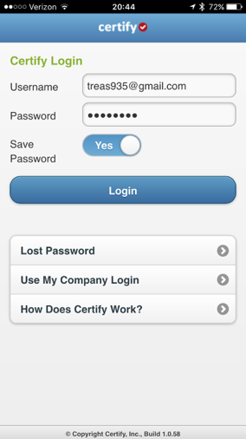
Log in using your email address. Your password should be local935
If it does not recognize your password click on “Lost Password”
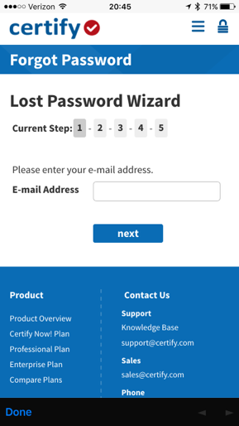
Follow the prompts in the “Lost Password Wizard” to reset your password to the password of your choosing
If you can not resolve the password issue please contact your treasurer immediately
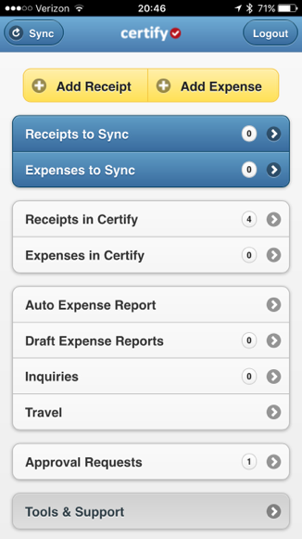
Once you have successfully logged in you will come to your home screen. From this screen you can add receipts, add expenses, create expense reports, and review which receipts you have already uploaded.
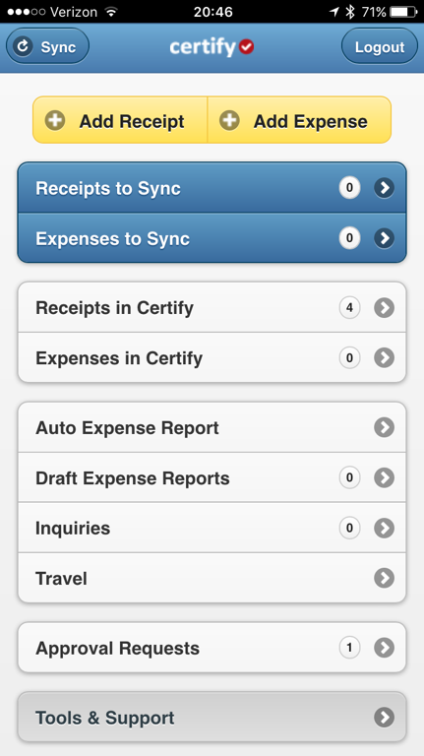
To add a receipt click “Add Receipt”
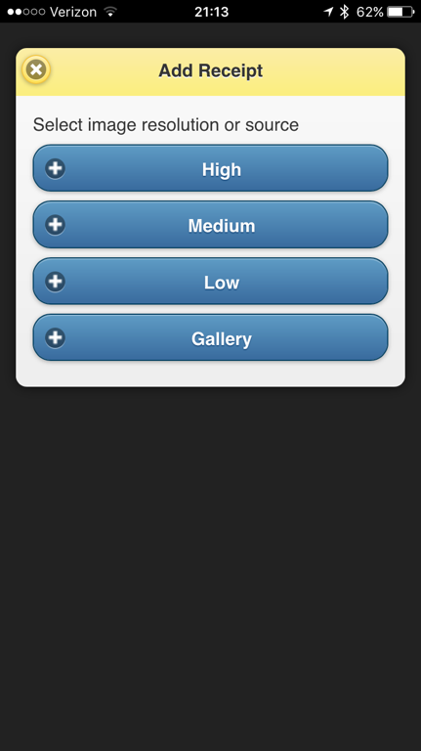
Select “High” resolution. If you have already taken a picture of the receipt, you can upload it from your picture gallery by selecting “Gallery”
Take a photo of both the ITEMIZED receipt, as well as the receipt that indicates the total you are paying. You may notice there is a shadow across this receipt, try to obtain the best lighting possible, however it does not need to be perfect, but must be legible. Per Local 935’s policy, expenses reported without itemized receipts will not be accepted and reimbursements may be denied or AMEX privileges may be revoked.
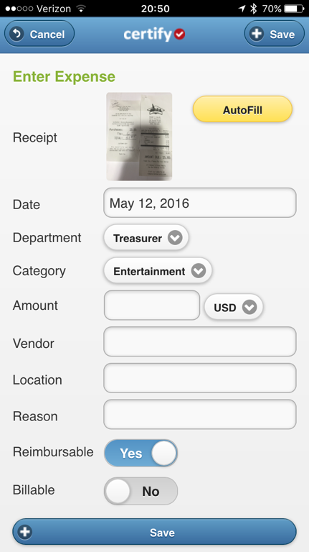
After you accept the photo, you will return to this screen, click “AutoFill” and the information from the receipt will be automatically entered into the associated fields. It is your responsibility to ensure that it is accurate.
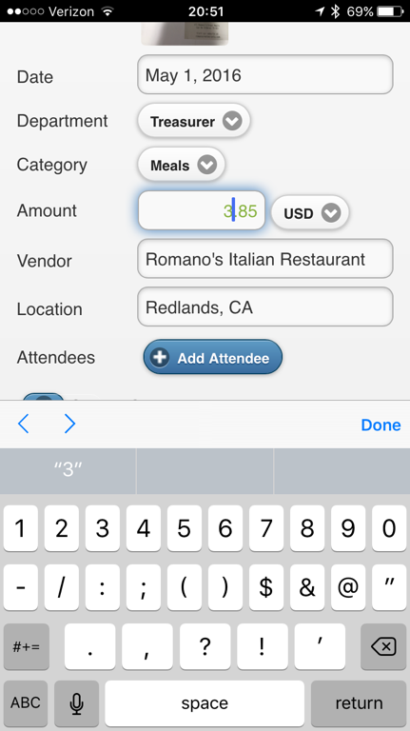
In addition to ensuring the amount is correct, please ensure that you have selected the correct “Department” i.e. President, Vice President, Representative, Etc. and select the appropriate category. I have used meals for this example however there are multiple categories and depending on the expense, you should select the category that best matches that expense. Categories will be revised as we use this program and find out what works best. Different information fields will be displayed depending on the category but all are self explanatory
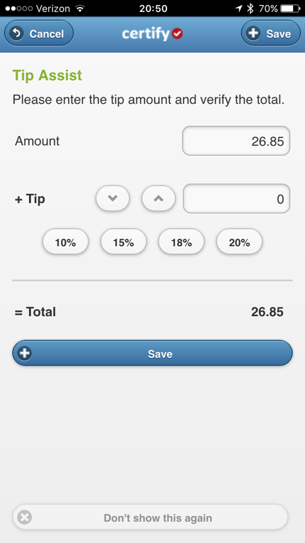
If there is a line for a tip, Certify will automatically launch tip assist. If this does not happen tip assist is most likely disabled and can be turned on in settings, which we will cover in a few slides. You can calculate a tip based on percentage, or simply enter whatever tip is already on the receipt.
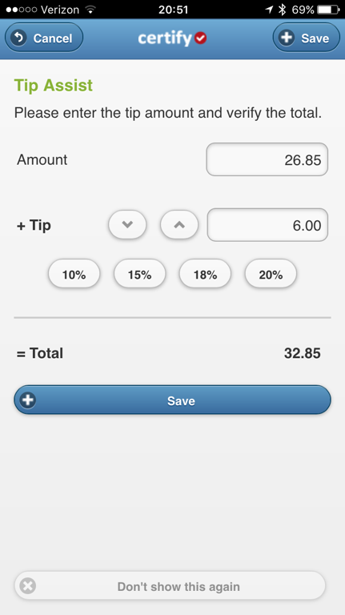
Tip is entered and the total is adjusted. Click “Save”
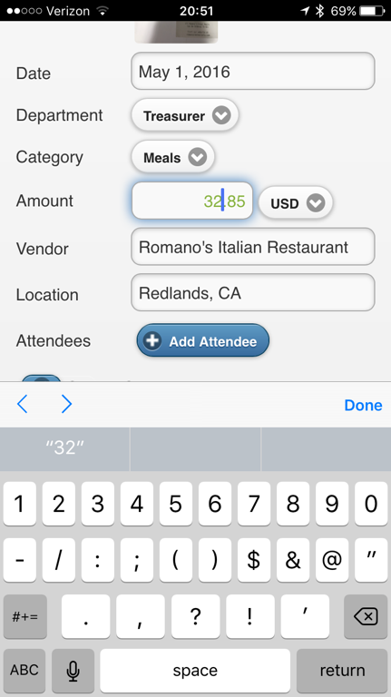
When Certify auto imported the data for this receipt, it was off by one dollar. Always ensure that the total matches the total on the receipt. It is a software program and not perfect.
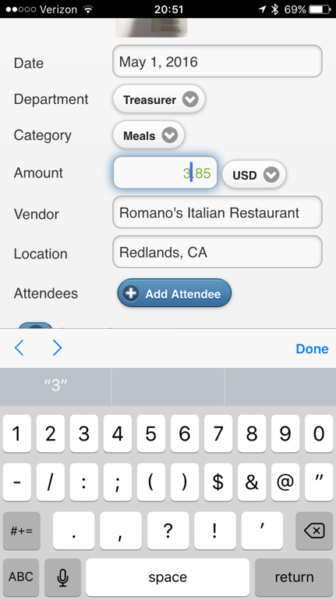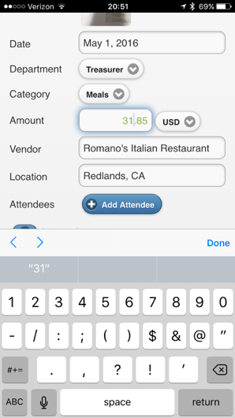
The total is now adjusted to match the total on the receipt 31.85
The next step is to click “Add Attendee”
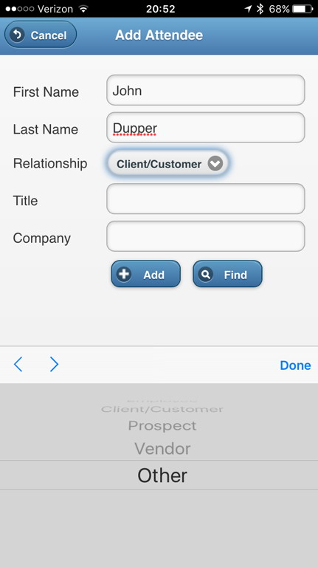
If unsure what to put for relationship, simply select other
Special Note* I realize that there are some instances where you may incur an expense for a large event or gathering where it would not be practical to list every attendee. Ensure that it is documented at some point what event the expense was for and the reason a list of attendees was not attached. Example “New hire orientation, 50 local 935 members in attendance"
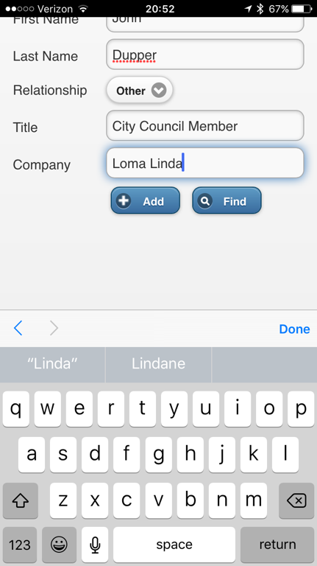
Complete the required fields and click “Add”
This person will be added to your attendee list and for future expenses with the same individual, simply type the first two or three letters of their last name and click “Find” select their name and their information will populate in the fields and not require you to input it manually every time.
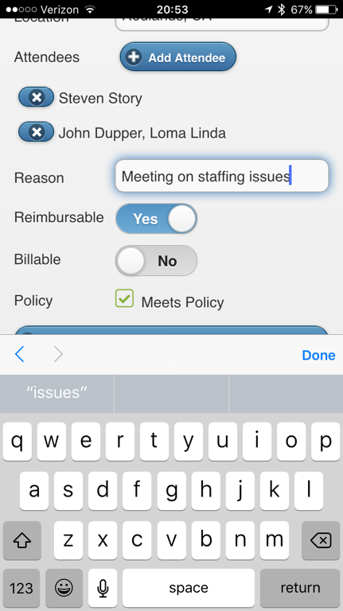
Enter a reason for the expense
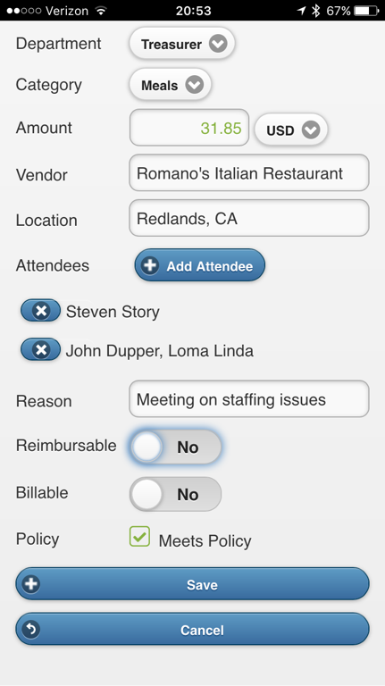
If the expense was paid for with an American Express card it is not reimbursable and the Reimbursable switch should be toggled to “NO”
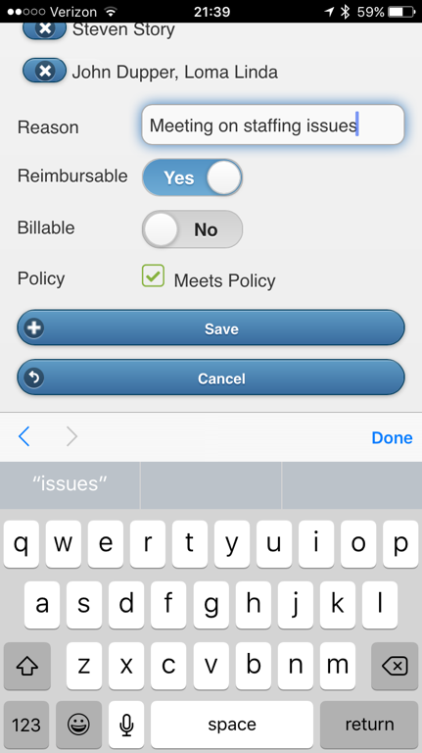
If you paid for this expense using your own funds ensure that the “Reimbursable” switched is toggled to “Yes” Then click “Save”
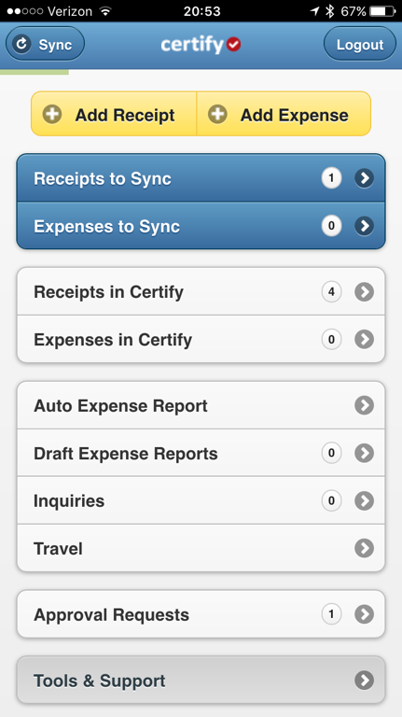
Finally click the “Sync” button in the upper left hand corner. If you would like Certify to automatically sync after every receipt or expense is entered (recommended) click on “Tools & Support” at the bottom of the screen
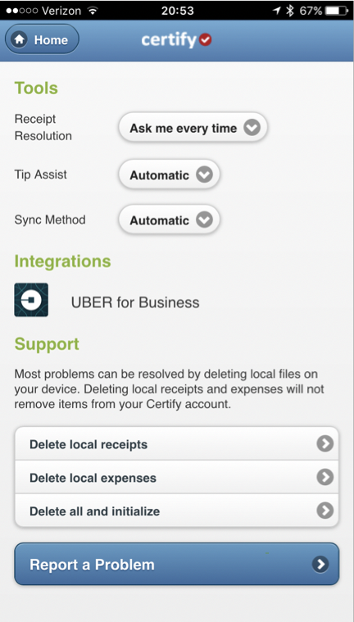
From this screen you can select your “Sync Method” to “Automatic” as well as ensure your “Tip Assist” is enabled and set to “Automatic” (Recommended)
To enter a mileage expense, click “Add Expense” The reason you are clicking add expense is because you do not have a receipt for the mileage, however Certify will generate one for you!
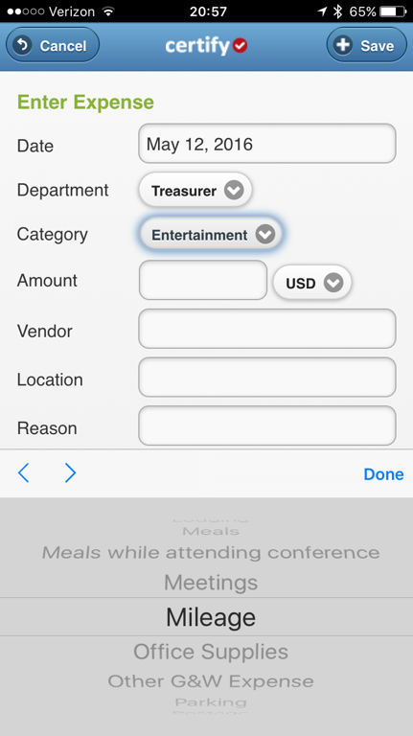
Select the “Mileage” category from the drop down menu
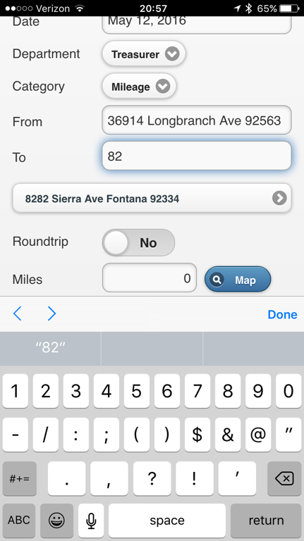
Enter the starting point “From” and the ending point “To” The first time you enter any address you will have to enter the entire address, however Certify will remember every address and predictively display them below the text field. Simply click on it and it will enter into the text field for you as shown here.
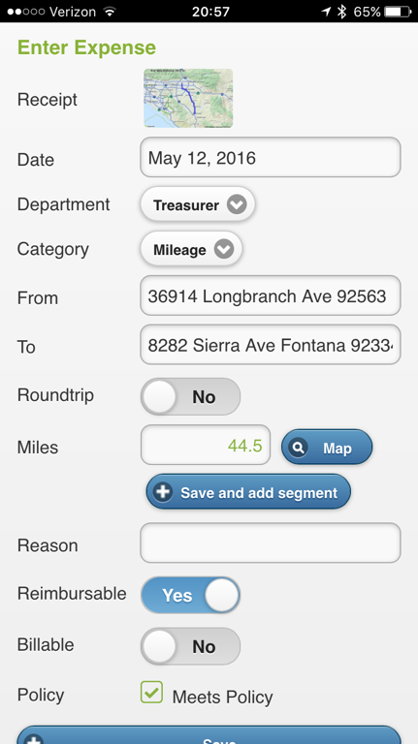
After you have entered a starting point and end point click “Map” and Certify will use map quest to give you the mileage for your trip. Certify will use the current IRS guidelines (.54/mile) to calculate the amount, however the amount will not be shown here, but it will be shown in your expense report.
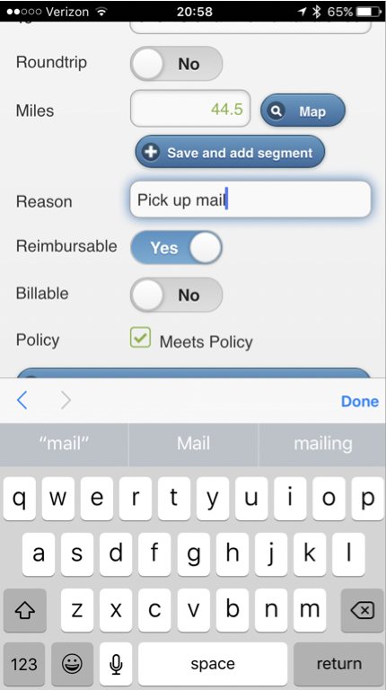
Enter the reason for your trip, and ensure that the Reimbursable switch is toggled to “Yes”
Finally click “Save”
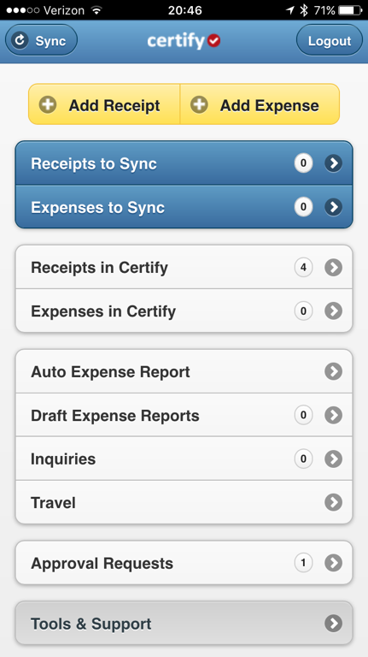
From our home screen you can determine how many receipts you have uploaded into the Certify program, in this case 4
Most members will not have any approval requests unless your are required to approve reports
The day before the end of the month, Certify will automatically generate an expense report for you. However, if you incur a large expense and need to be reimbursed sooner, you may do so by clicking “Auto Expense Report”
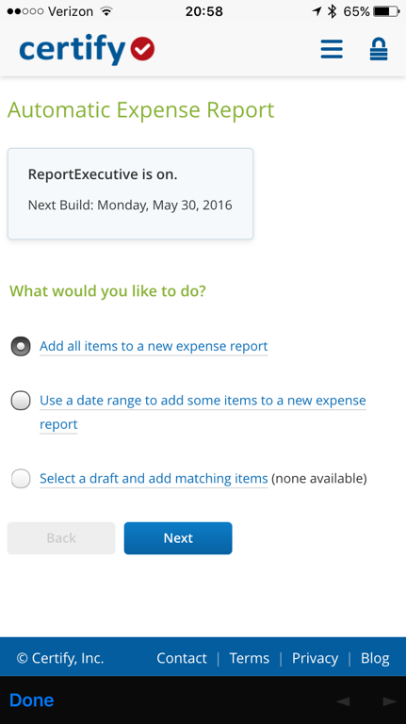
ReportExecutive is the feature that automatically creates your expense report, and you can see then next day it will do so is May 30th
To create an expense report, you can add all the receipts currently in certify, or a specific date range to add to a new expense report (the day the large expense was incurred)
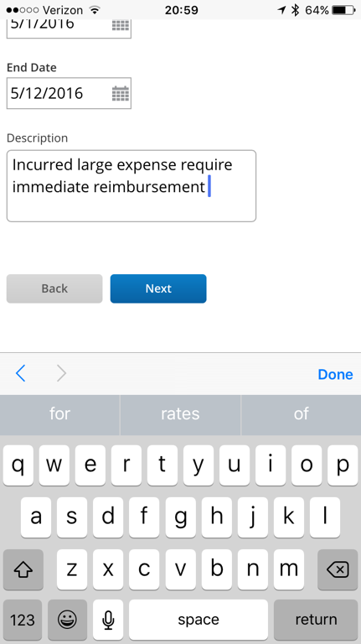
In the description, explain the reason for immediate reimbursement
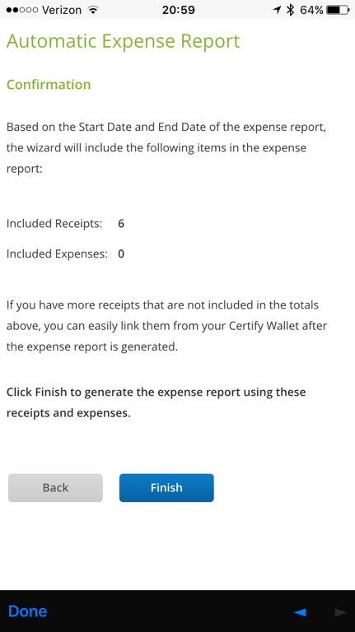
The tool will tell you how many receipts are included in this report, select “Finish”
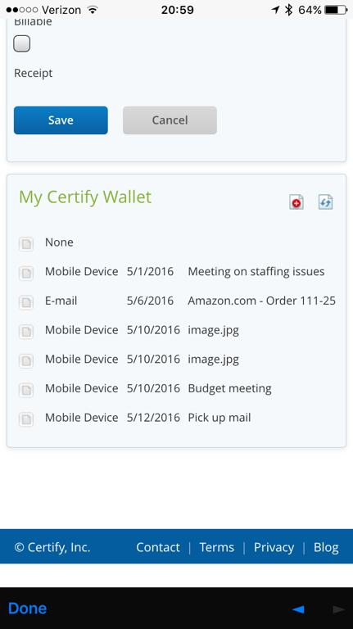
All the receipts from your Certify Wallet have been added. If there were additional receipts that we not added, there would be a green plus sign next to the receipt, you would click it to add the receipt.
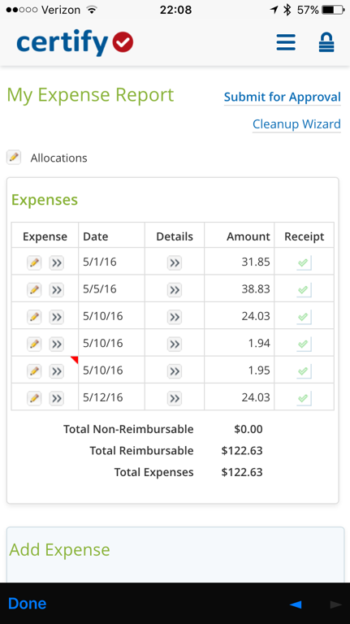
Any receipt that still requires your attention will have a red flag in the corner. Click on “Cleanup Wizard” to correct these red flags
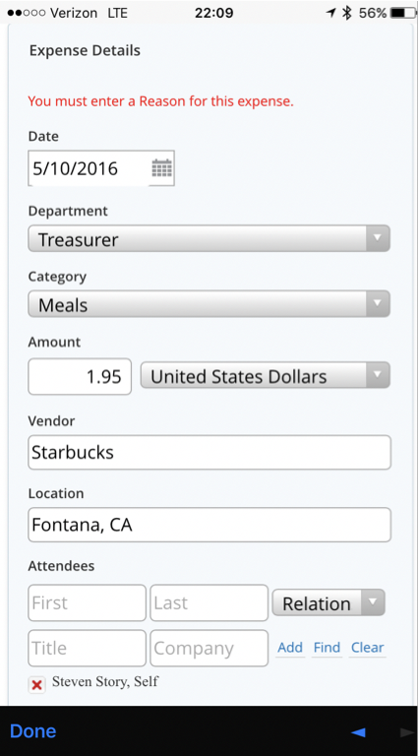
For this receipt I forgot to enter a reason for the expense
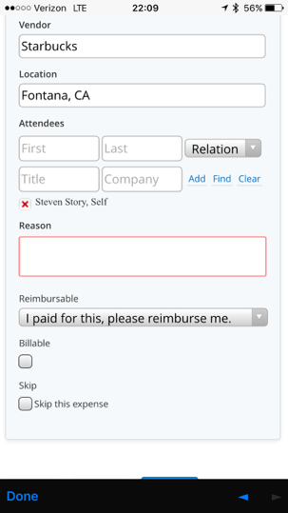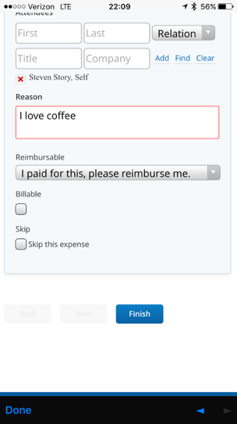
Once I enter my reason I click Finish. If there were multiple receipts to correct I would click “Next”, correct each one, and when they were all correct I would then click “Finish”
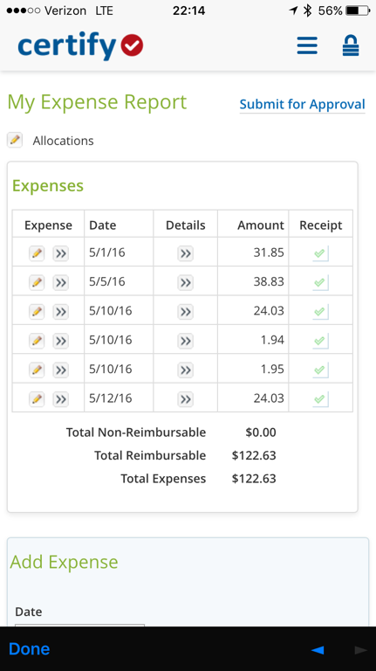
Once all your red flags have been resolved, click “Submit for Approval” Remember, Certify will automatically generate the report, but you will have to ensure that the receipts are accurate, there are no red flags, correct them, and then submit for approval.
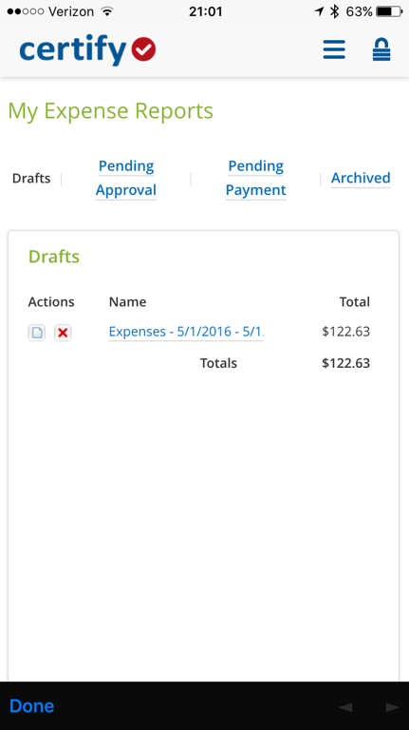
You can view you expense reports by clicking “Draft Expense Reports” from the home screen. You are also able to see what stage of the approval process your expense report is in. Once your expense report has been approved, processed and paid, it will remain in the archived section of your “My Expense Reports” folder.
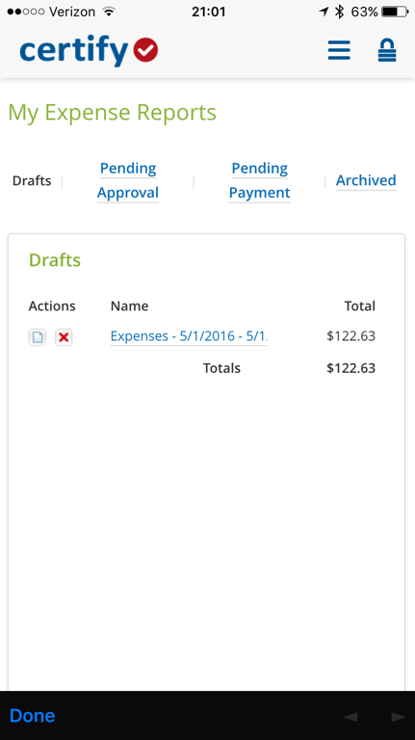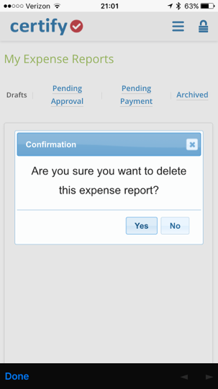
You can also delete and expense report by clicking the red X next to the expense report you wish to delete. Deleting the expense report will NOT delete the receipt. Receipts will be put back in your Certify Wallet.
This concludes the Mobile App portion of how to add receipts, expenses, and submit expense reports using the Certify program. I have tried to make this guide as simple as possible breaking down each step answering as many questions as possible. I realize that improvements can and should be made to this guide to answer questions and address issues it may not currently cover. My goal is to help those using this program be able to efficiently and accurately track and report their expenses.
The remaining portion of this guide is to demonstrate the web based Certify Dashboard. All functions and features of Certify can be completed with a mobile phone, however it may be preferable for some to use the web based dashboard as well.
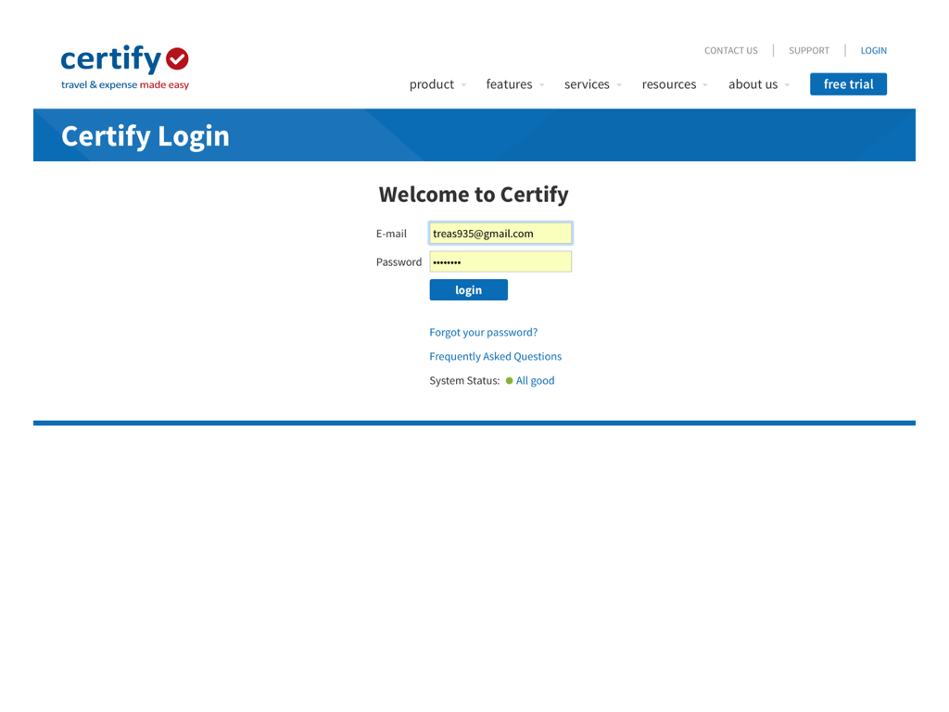
Log into Certify with the same information as logging in from your Mobile App
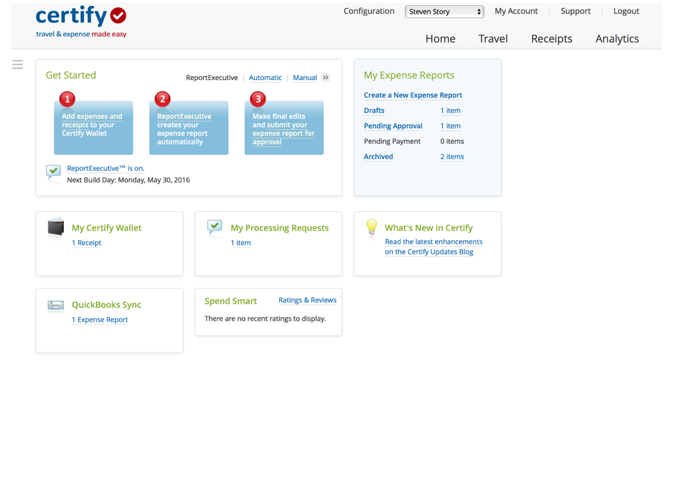
This is your home page, yours may look slightly different than mine however it functions the same as your mobile app.
Your “My Certify Wallet” is where your receipts are kept. These are the receipts that have not been added to expense reports yet.
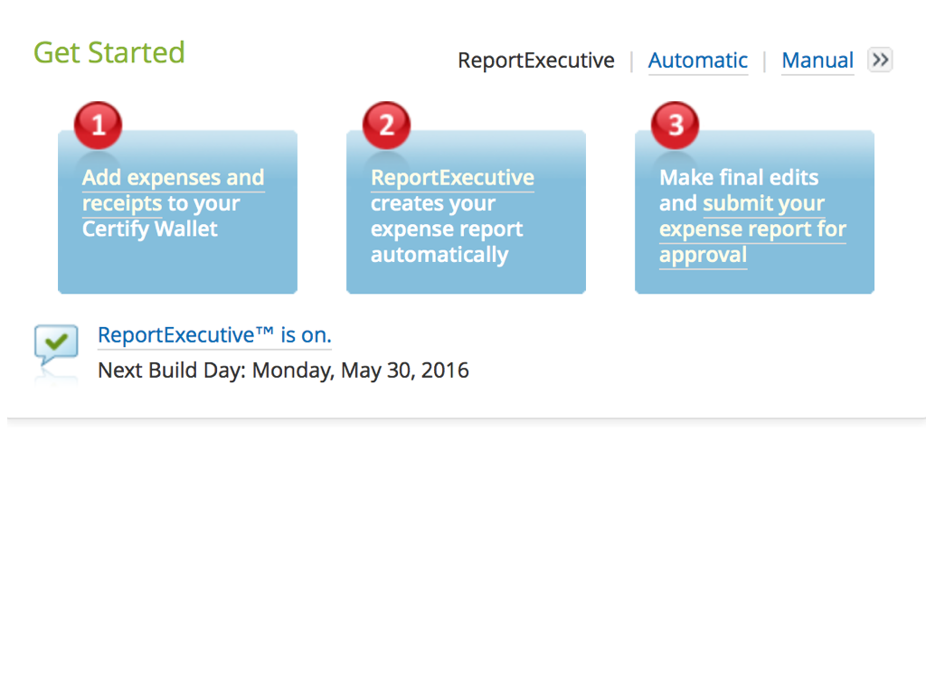
Expense reports are generated automatically by Report Executive on the day before the last day of the month. You will receive an email reminding you to add any outstanding receipts to your certify wallet. Receipts may be added from your Certify wallet to any existing expense report at any time.
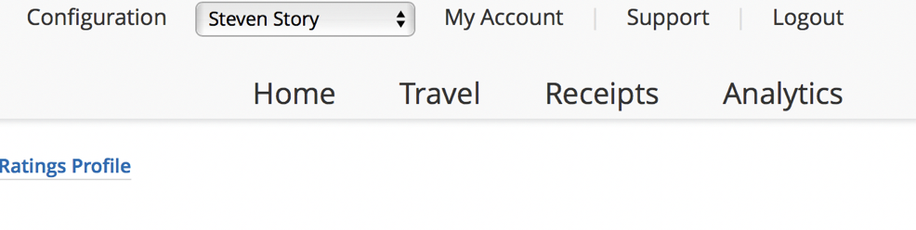
In the upper right hand corner you have navigation buttons to access various features of the dashboard
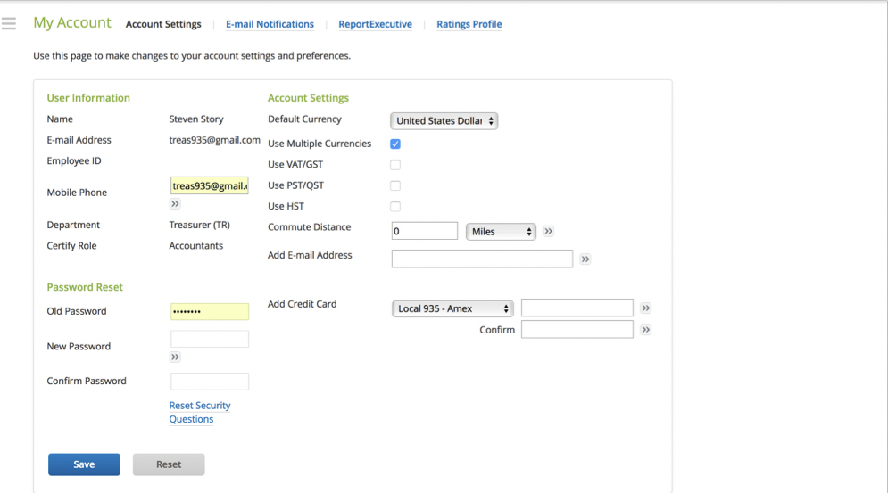
Please DO NOT enter any credit card information
From the “My Account” page, you can update your phone number, email address, as well as change your password
If you make an online purchase, or have a receipt that is in PDF format, you can email it to data@certify.com, and it will be uploaded to your certify wallet automatically.
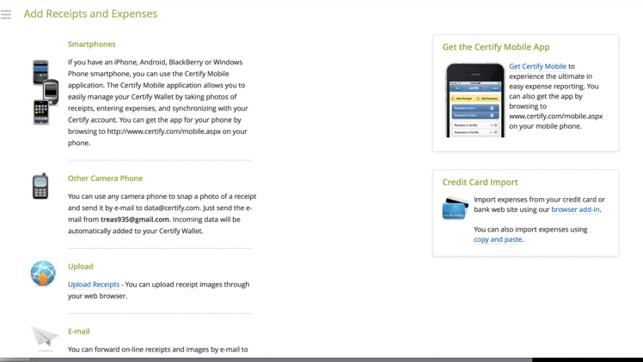
There are several methods of uploading receipts and they are accessible from the “Receipts” tab on the dash board.
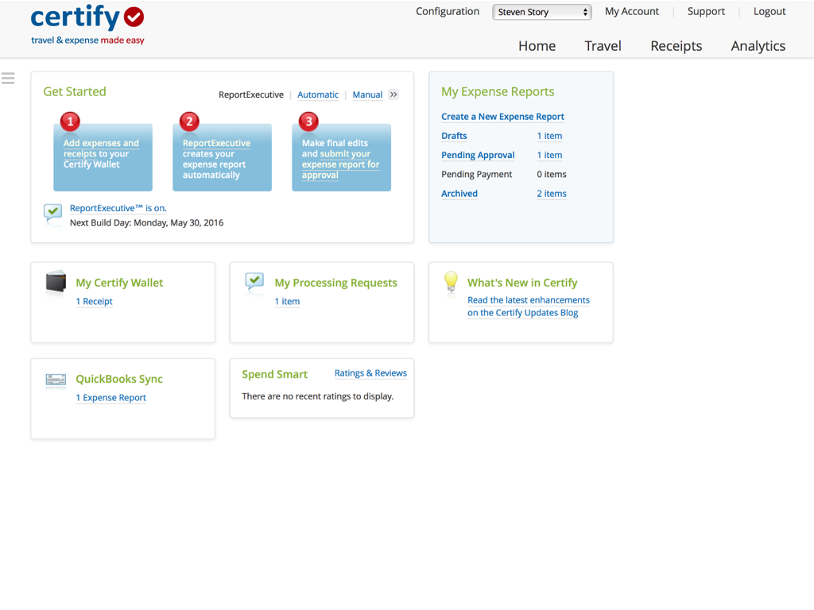
If you wish to create an expense report, click on “Create a New Expense Report”
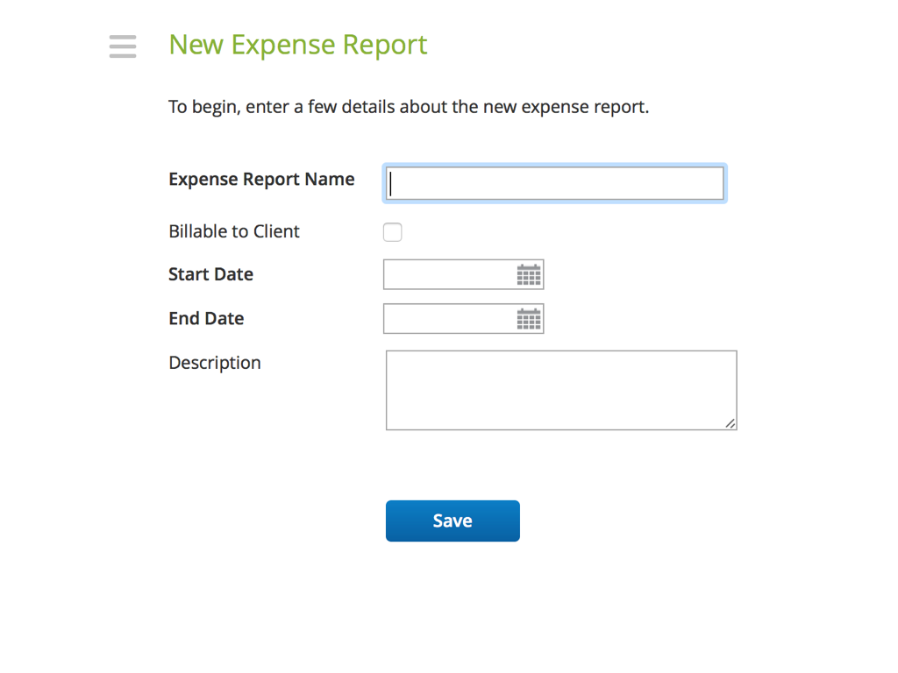
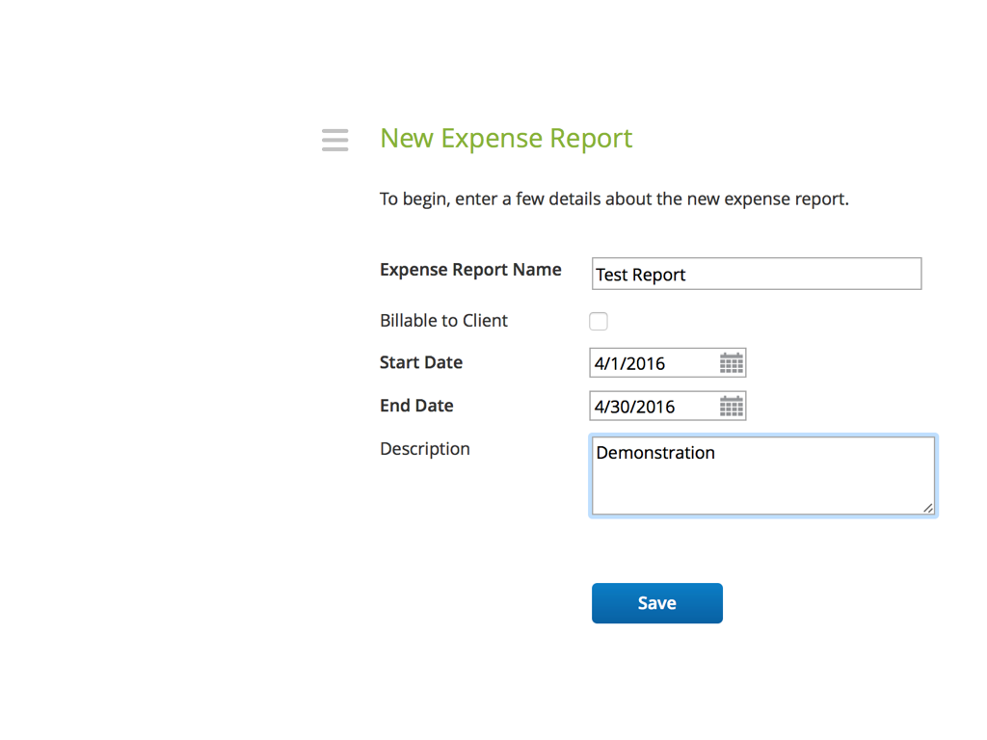
Tittle your expense report and in the description you may indicate the reason for creating it i.e. April Expenses or incurred large expense for member event
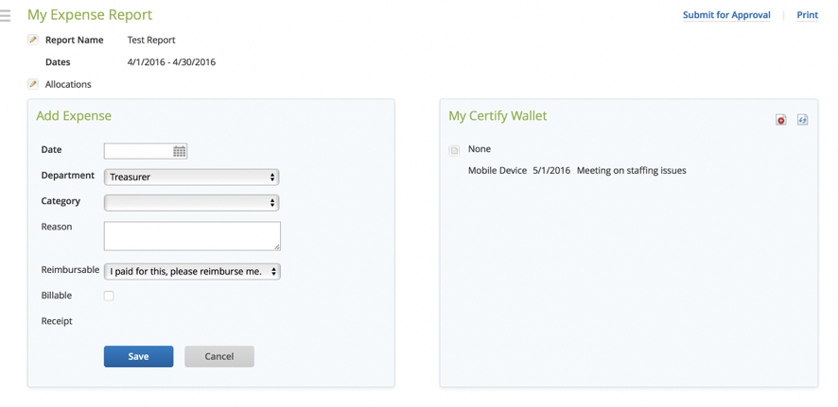
You can select the receipts you would like to add from your certify wallet. Always ensure that the information on the receipt is accurate.
When completed click submit for approval.
This concluded the users guide for certify. Thank you for your time in reviewing this guide. If you have any suggestions or questions please email your treasurer at treas935@gmail.com

APPENDIX M
Chow Fund Buyer Procedures
Chow fund buyers are to contact David Lille at Firefighters First Credit Union.
DLillie@firefightersfirstcu.org
(909) 641-9501
Inform him that you are the chow fund buyer for your station. He will open a FREE checking account at the credit union where chow fund monies will be deposited. He will transfer any remaining monies from the previous buyer to your account. These funds are SEPARATE from your personal funds and cannot be over-drafted.
Once the account has been set up you will receive a debit card linked to that account.
Notify the treasurer of the change and he will update the chow fund spreadsheet accordingly.

